# Persistent XSS Attack

## Explanation of XSS Vulnerability

The cause of a XSS vulnerability occurs when attackers inject destructive scripting code to pages that different users view. Script files operate in user browsers to steal sensitive information containing session cookies followed by login credentials as well as unauthorizedly execute commands as if the users themselves approved these actions. Several types of XSS attacks exist having Persistent and Reflected and DOM-based properties. The server runs harmful scripts from Persistent XSS by saving them directly in its database for execution at page load time. XSS prevention becomes possible only through combining input validation with sanitization along with output encoding to protect user systems (Tadhani et al., 2024).

## Attack Demonstration

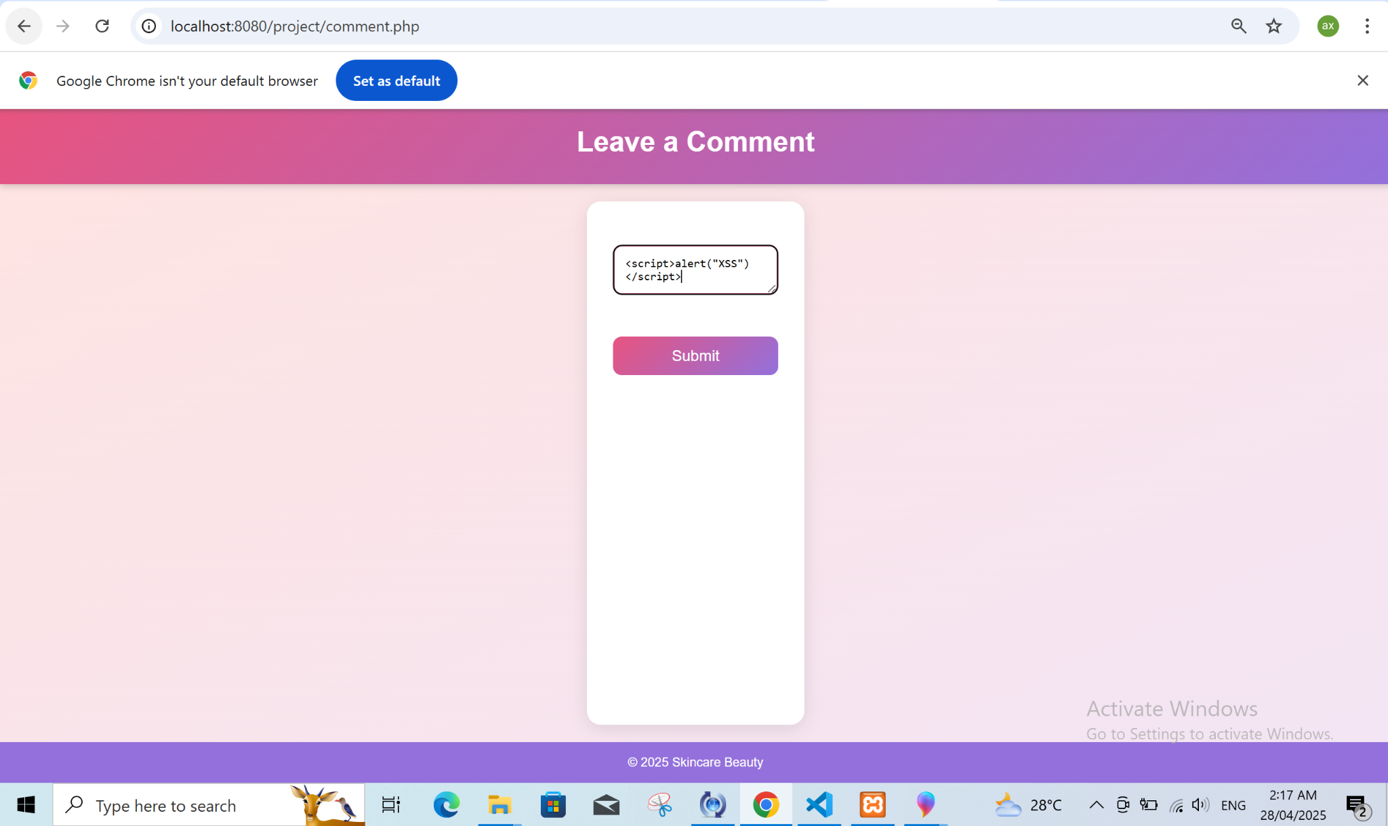

Figure 35. XSS Attack Script

The Persistent Cross-Site Scripting (XSS) vulnerability seems to be explained in this figure. Through this figure one learns about the vulnerability's dynamics as attackers inject harmful scripts into the comment area which stay visible upon users viewing the comments.

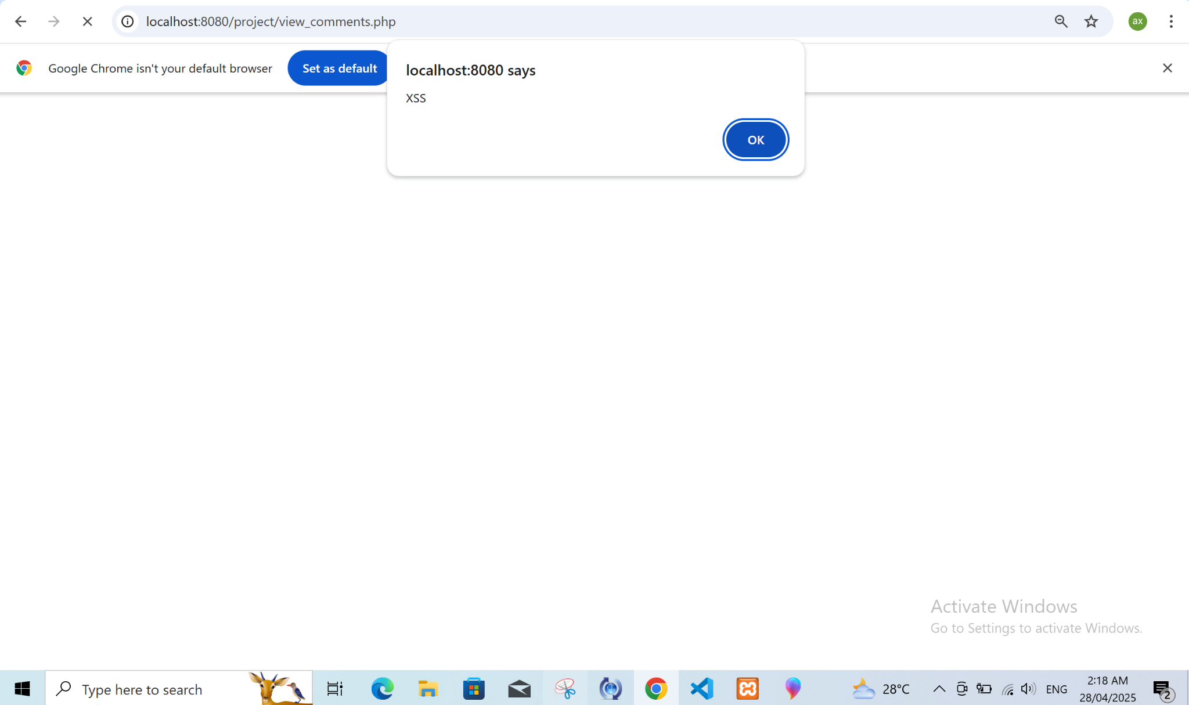

Figure 36. XSS Attack Demo

The screenshot or code demonstrates the actual implementation of Persistent XSS attacks. When using malicious scripts the input code within the comment section embeds the attack procedure which activates upon page loading for other users.

## Mitigation

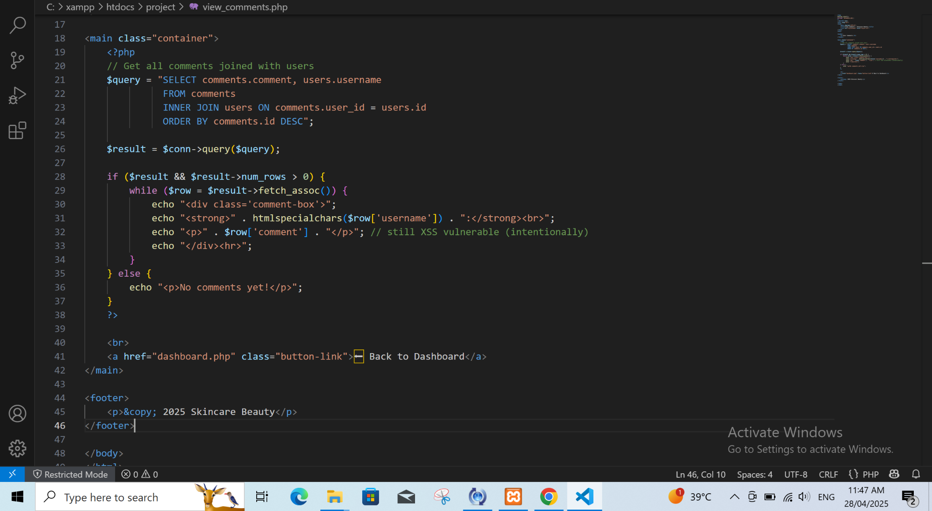

Figure 37. Before XSS Mitigation Code

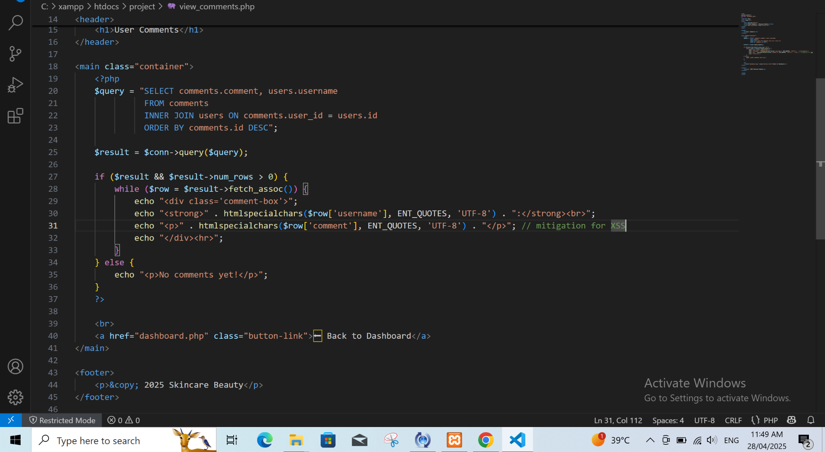

Figure 38. XSS Mitigation Code

The illustrated solution demonstrates how to prevent XSS attacks in this figure. The solution cleans input data to stop harmful execution of symbols <, >, @ and $ and more.

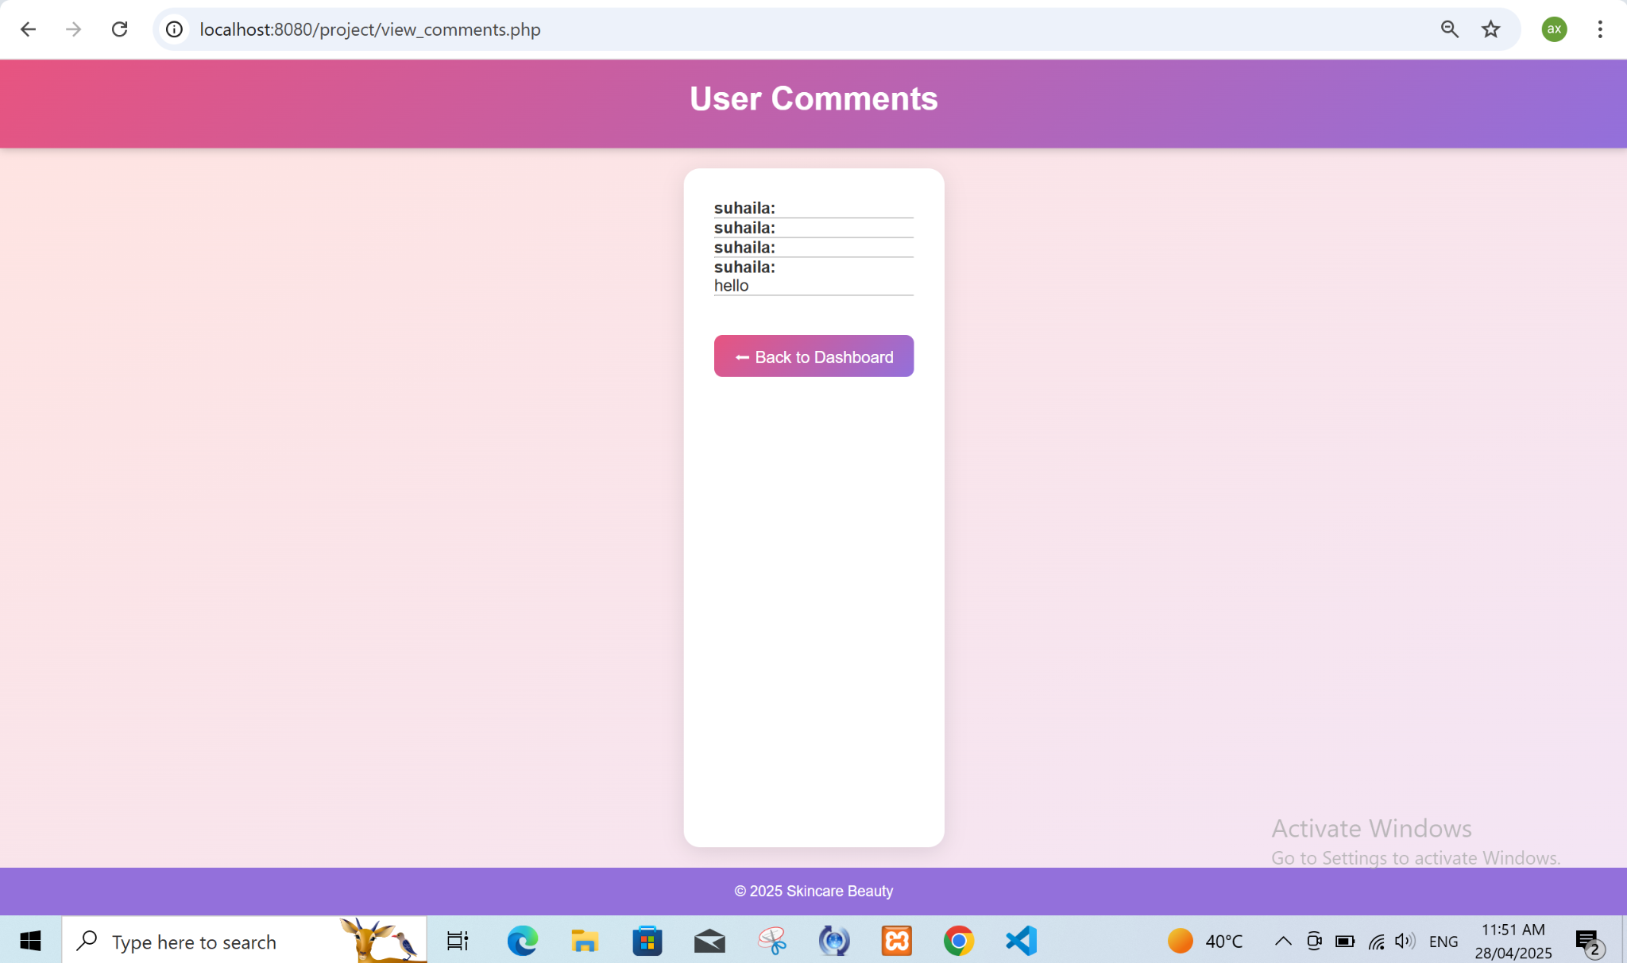

Figure 39. Pre-Mitigation Comments View

The comment section displayed in this figure after the mitigation shows no harmful scripts execute because of the security measure that prevents XSS.

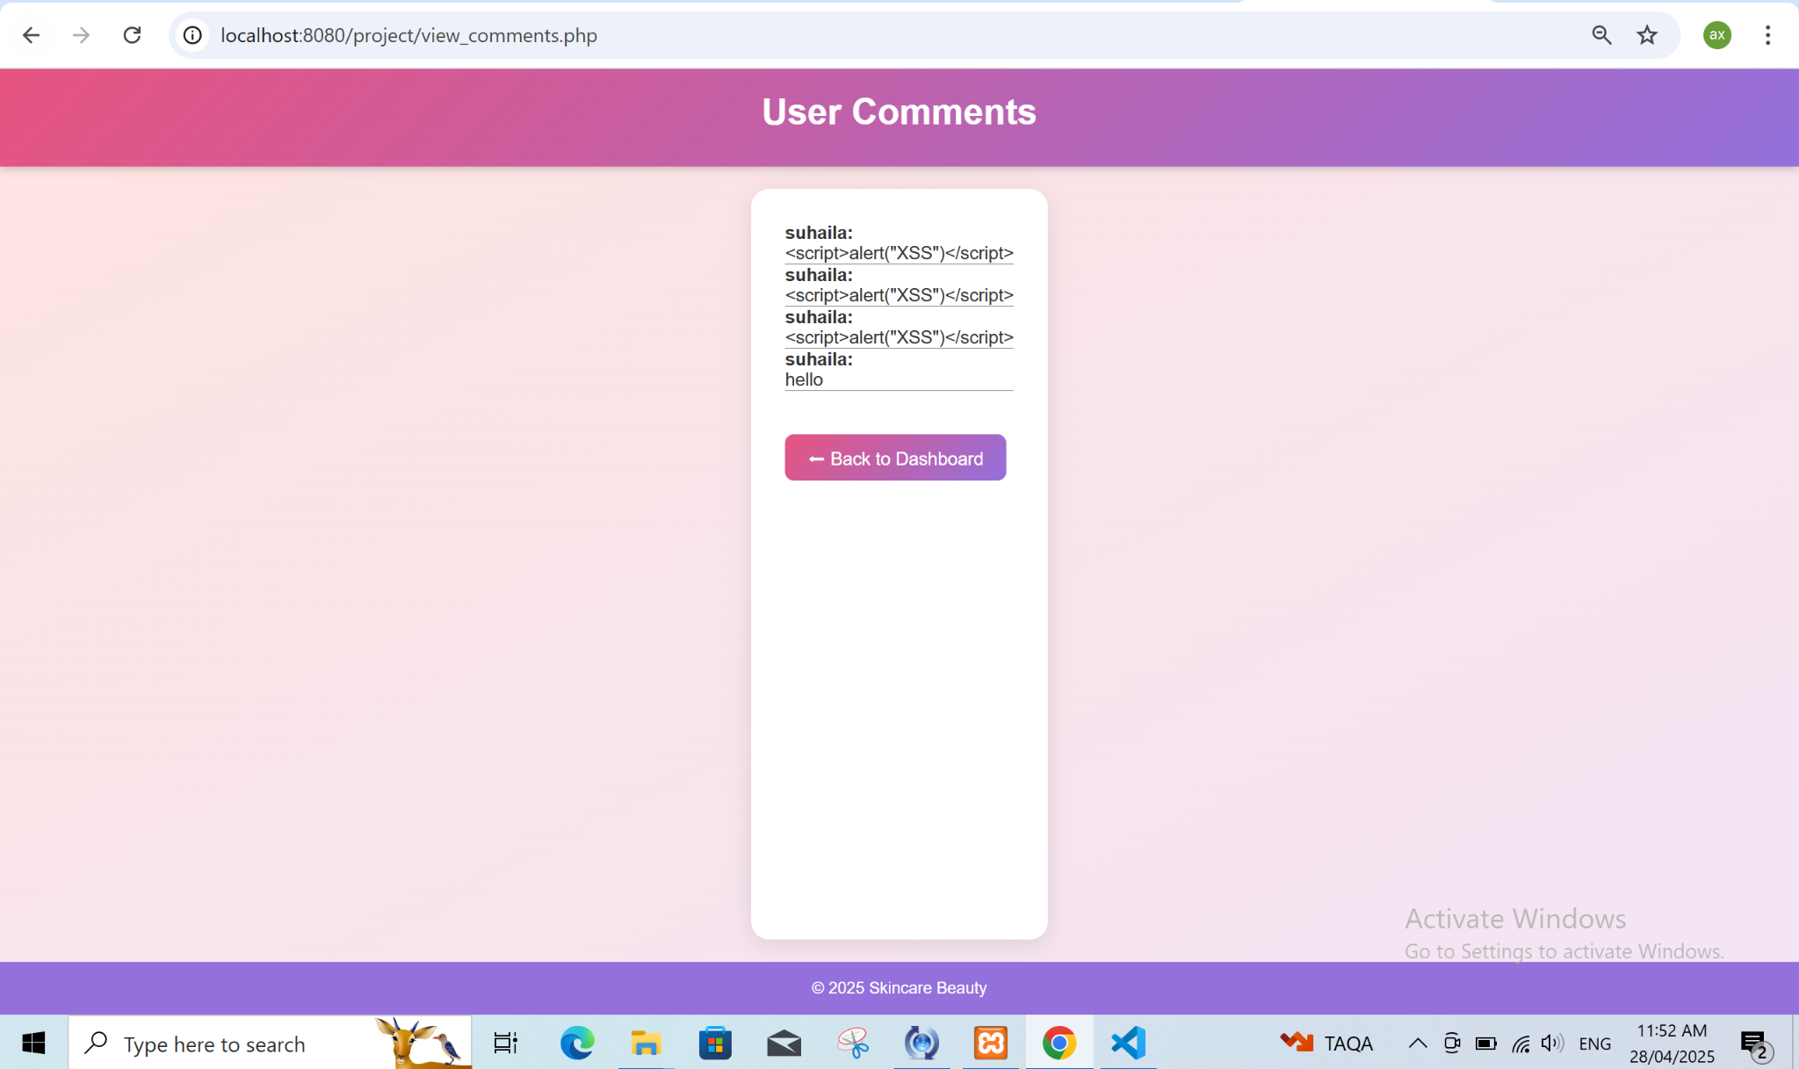

Figure 40. Post-Mitigation Comments View

The illustration depicts SQL Injection vulnerability with an explanation showing how attackers introduce harmful SQL code through login page input fields to control SQL queries.

# Simple SQL Injection Attack

## Explanation of SQL Injection Vulnerability

A SQL Injection attack occurs through the process of manipulating web application SQL queries by adding improper SQL code to user input data fields. By accessing the database through this method the attacker can manipulate the records along with performing administrative operations on the database. Software applications remain vulnerable to SQL Injection attacks because they lack suitable methods for input validation combined with proper sanitization techniques. Attackers exploit the database by placing SQL code in specific input boxes like login fields and search fields which causes databases to run unexpected commands. Preventing SQL code execution depends on parameterized queries with prepared statements as well as input value validation methods and user input escape techniques to stop query manipulation by SQL commands. Database account privilege management based on the principle of least privilege helps limit damages between successful SQL injections (Demilie & Deriba, 2022).

## Attack Demonstration (Screenshots & Code)

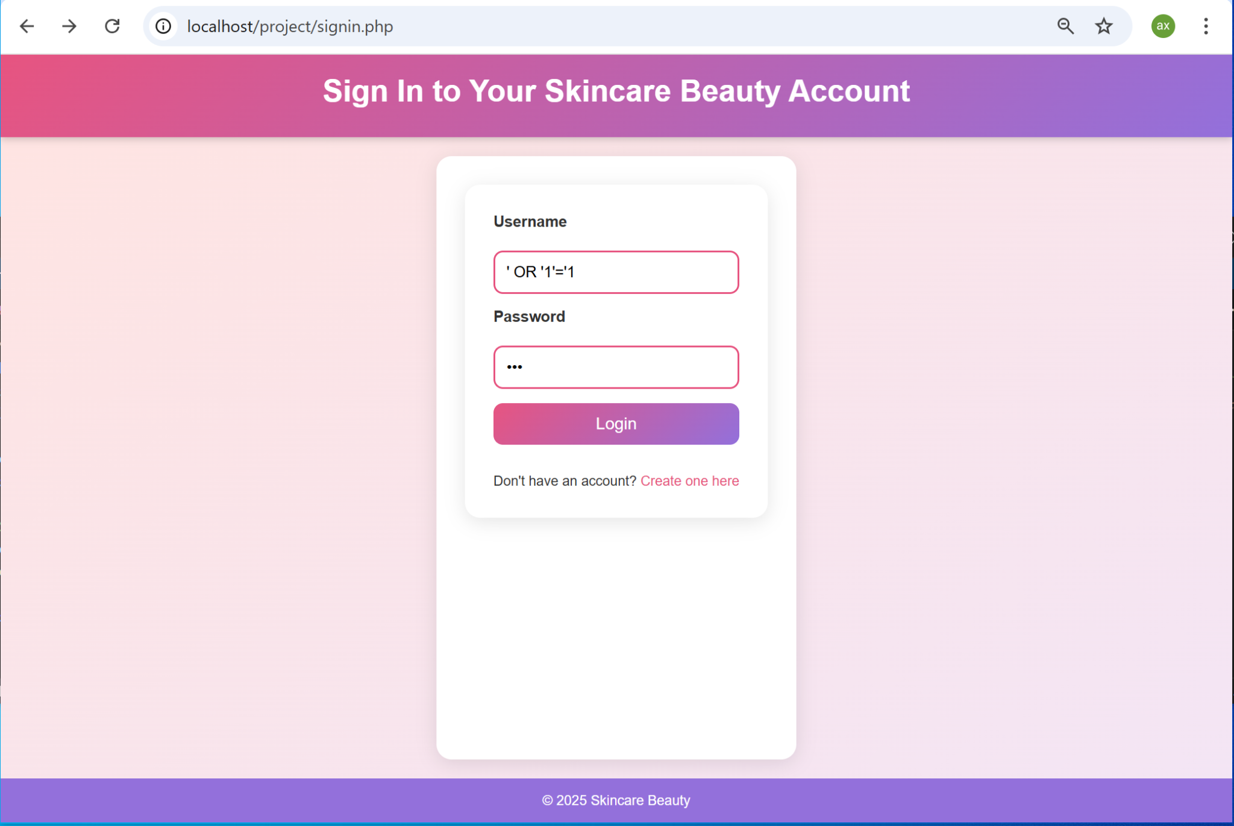

Figure 41. SQL Injection Explanation

The SQL Injection attack can be observed in this illustration. The combination ' OR '1'='1 inputted to username or password fields enables unauthorized login because it bypasses authentication procedures.

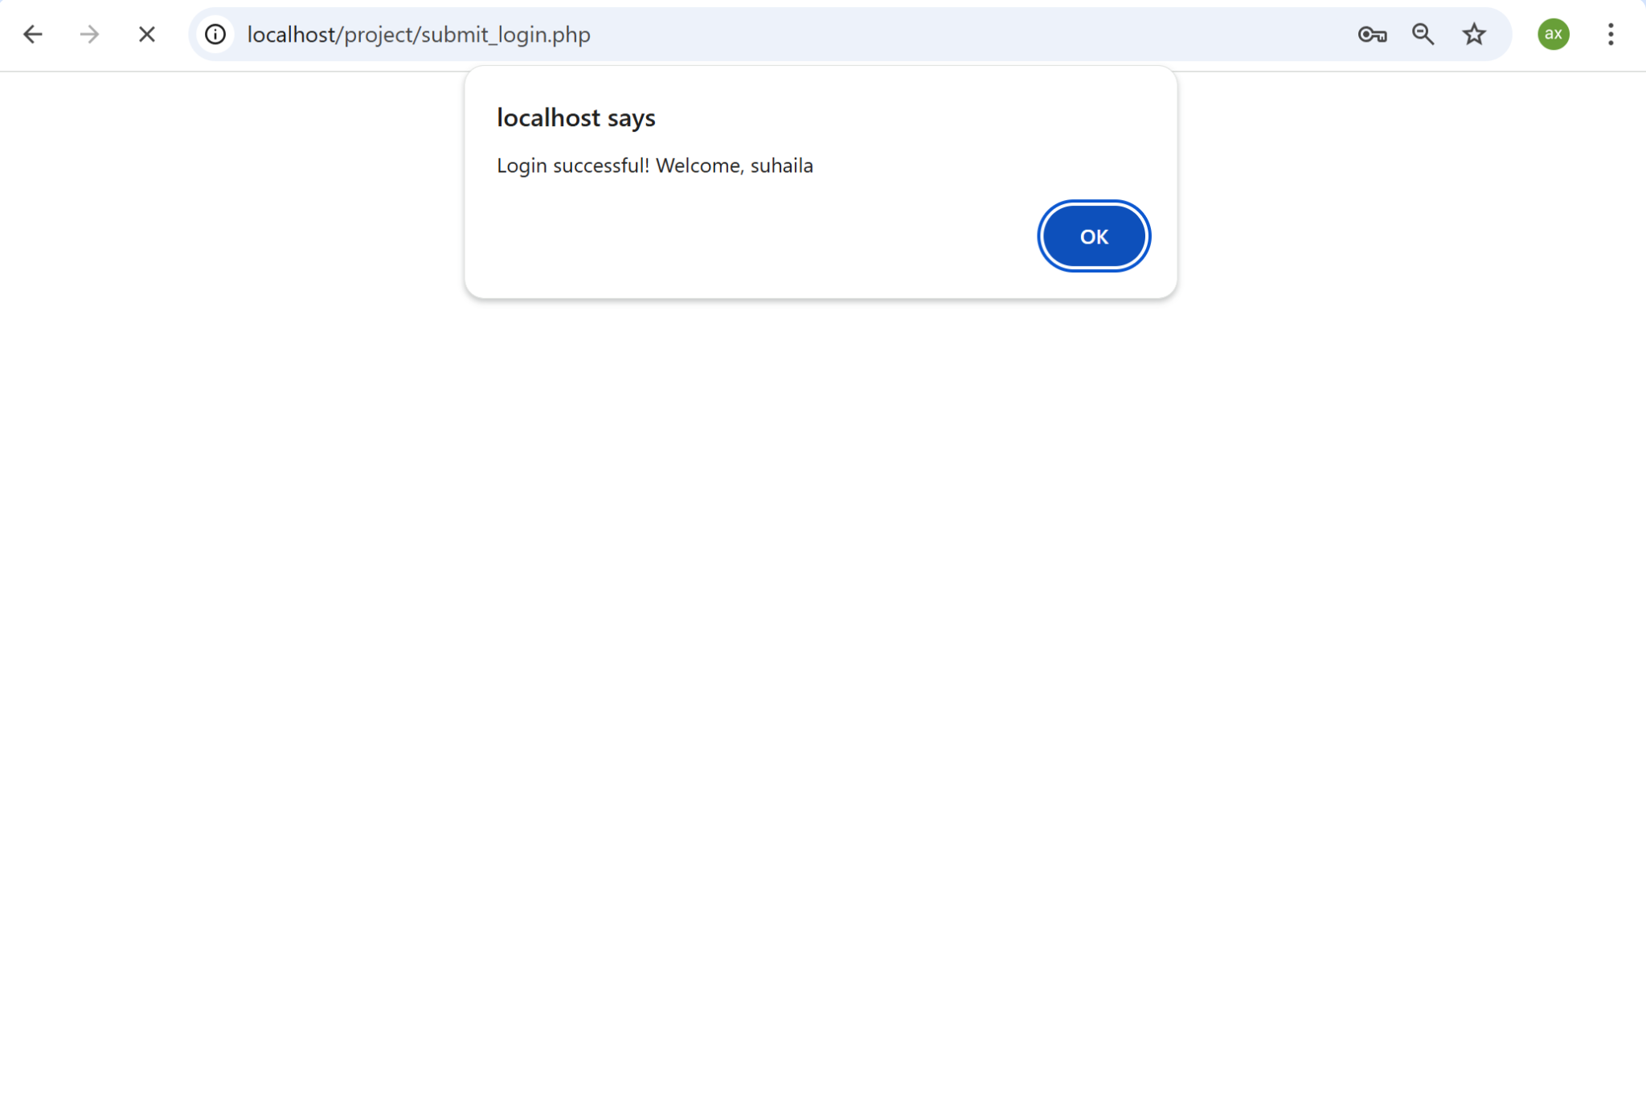

Figure 42. SQL Injection Demo

The figure depicts an SQL Injection outcome which allows unauthorized access to the website because the "Welcome" message appears after successful login.

In submit_login.php:

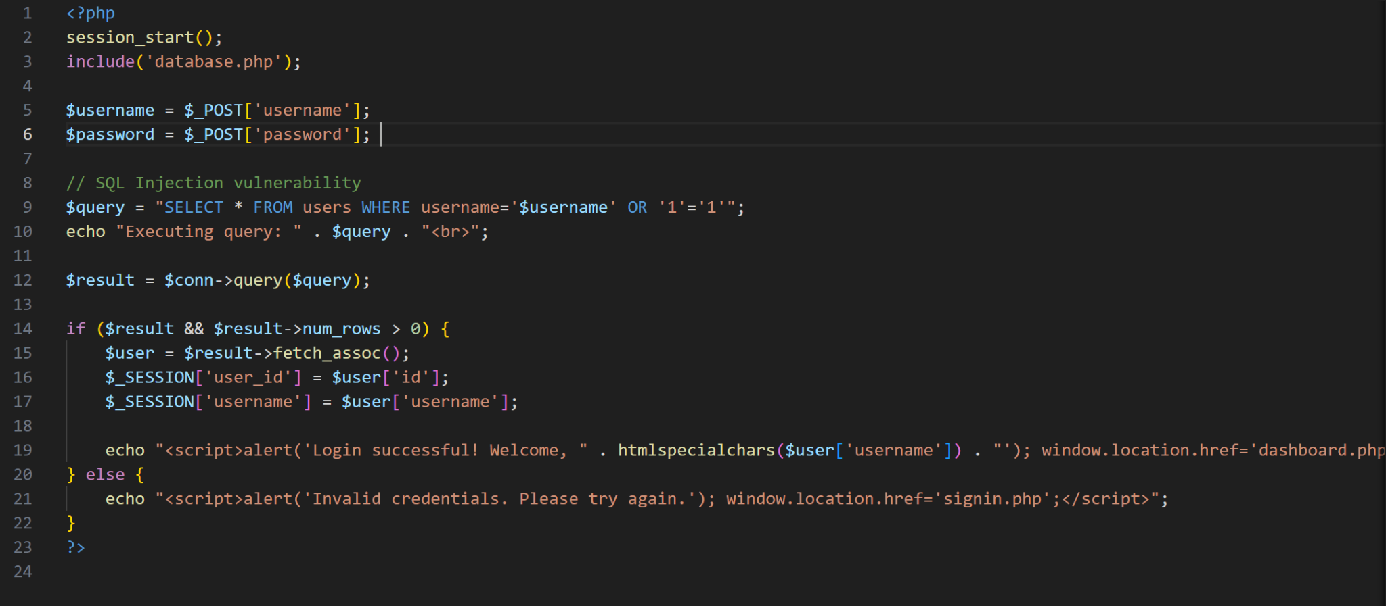

Figure 44. SQL Injection Code

An illustration provides the execute SQL injection code present in the submit_login.php script. The security weakness emerges from insufficient input validation or the absence of sanitization methods.

In Signin.php:

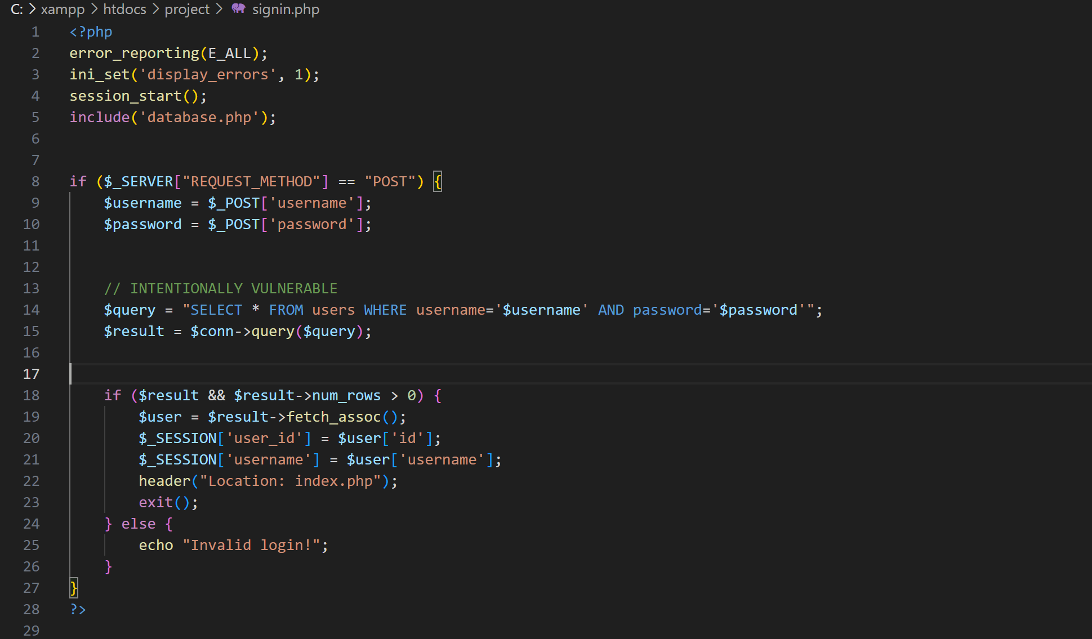

Figure 45. Signin.php Vulnerability

The presented file might be signin.php because the vulnerability appears to exist within it. The system transmits user input information right into the unsecured SQL command.

## 

## 

## Mitigation

In Signin.php:

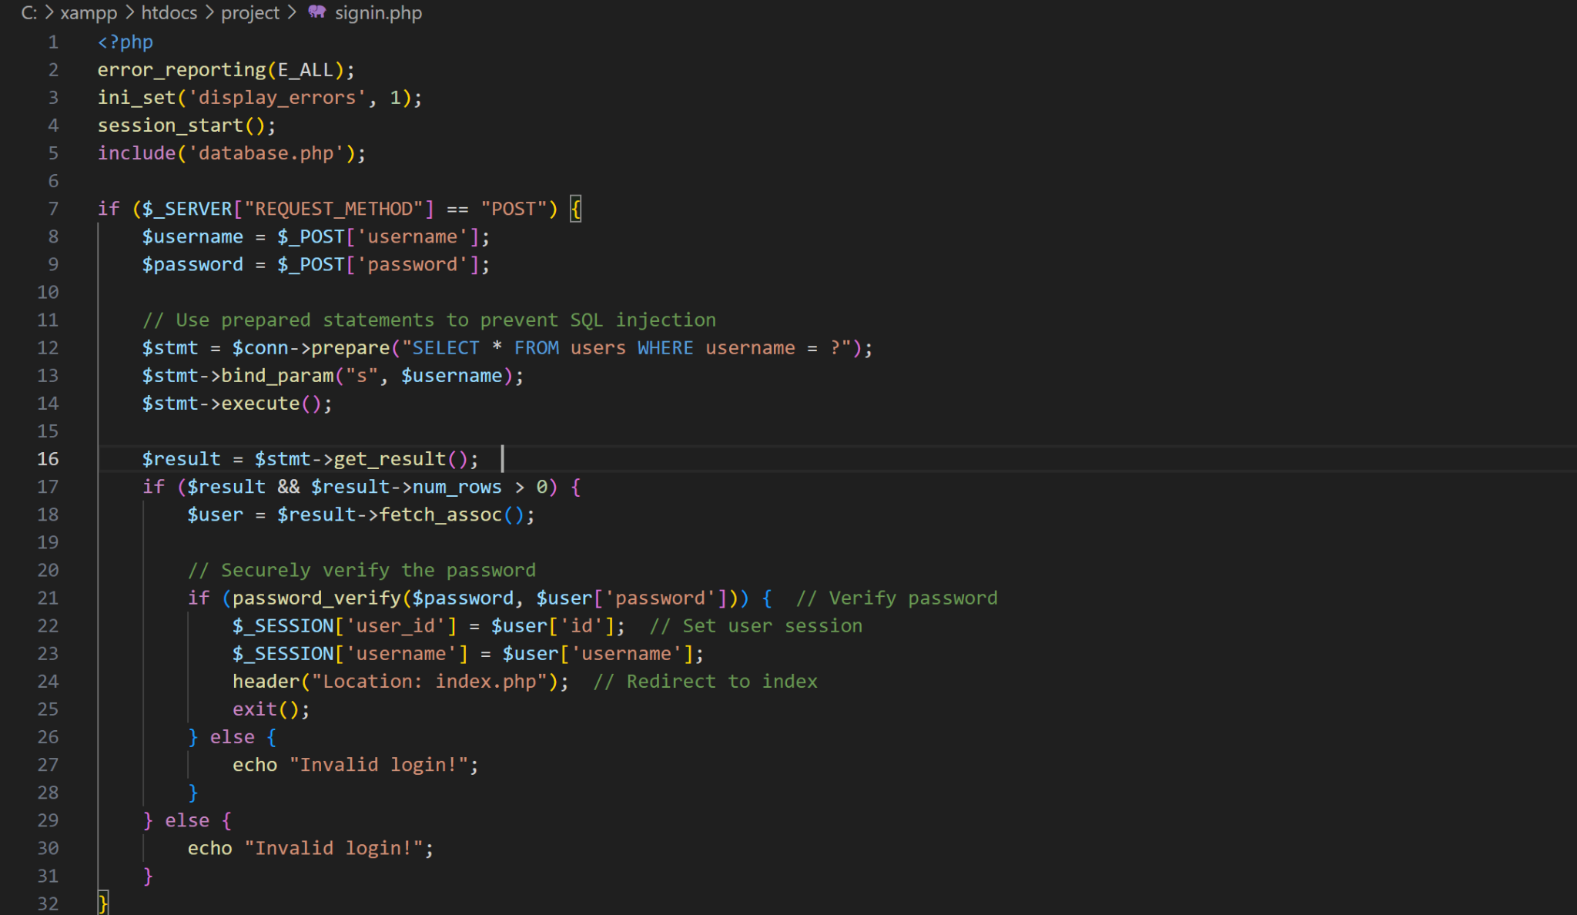

Figure 46. Signin.php After Mitigation

The updated signin.php file most likely appears in this figure which displays the secure code dedicated to protecting user input from SQL Injection.

In Submit_login.php:

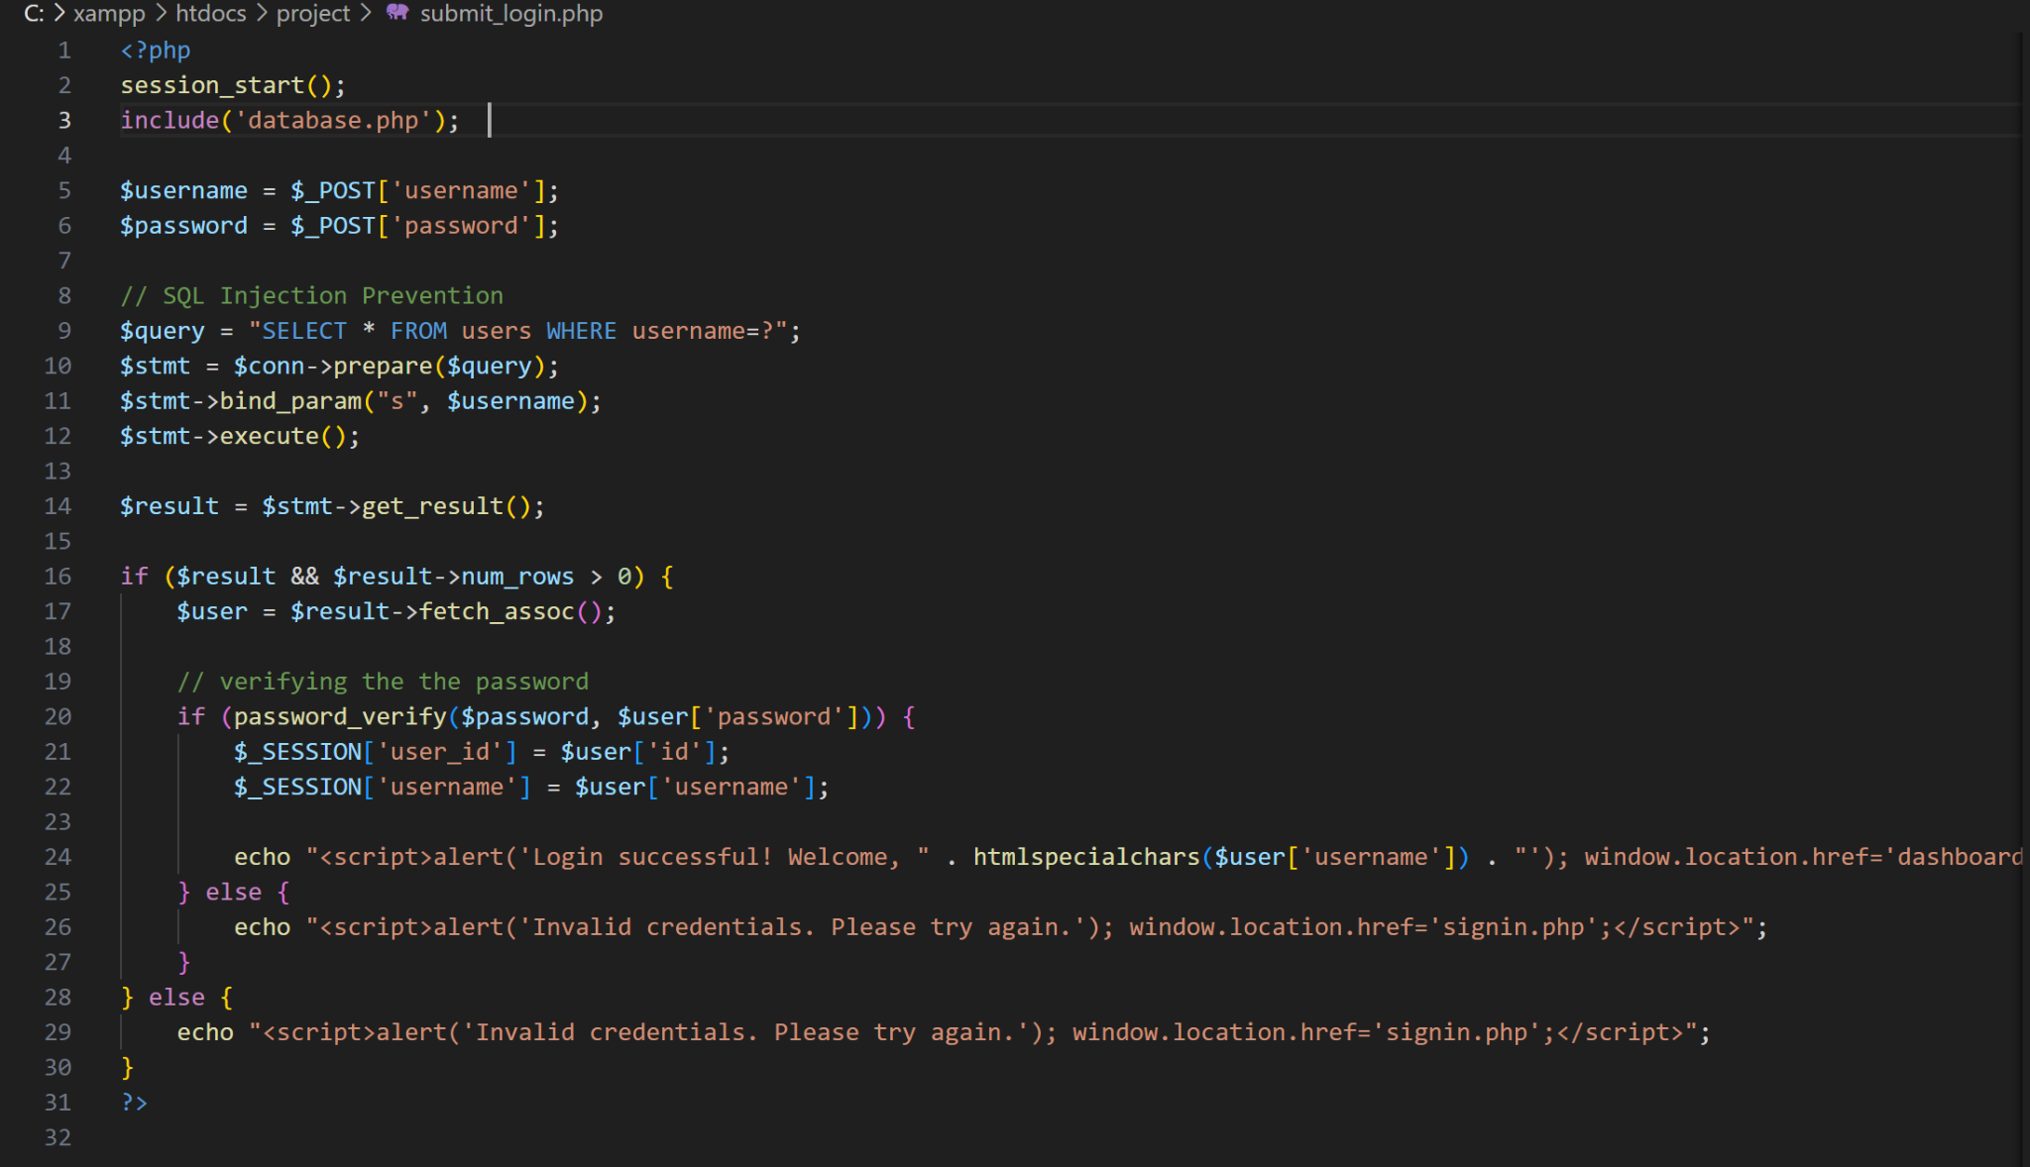

Figure 47. Submit.php Code

The provided figure shows the exact execution of an SQL Injection attack through which attackers use SQL commands to circumvent login procedures. The figure displays both attack details while presenting system responses.

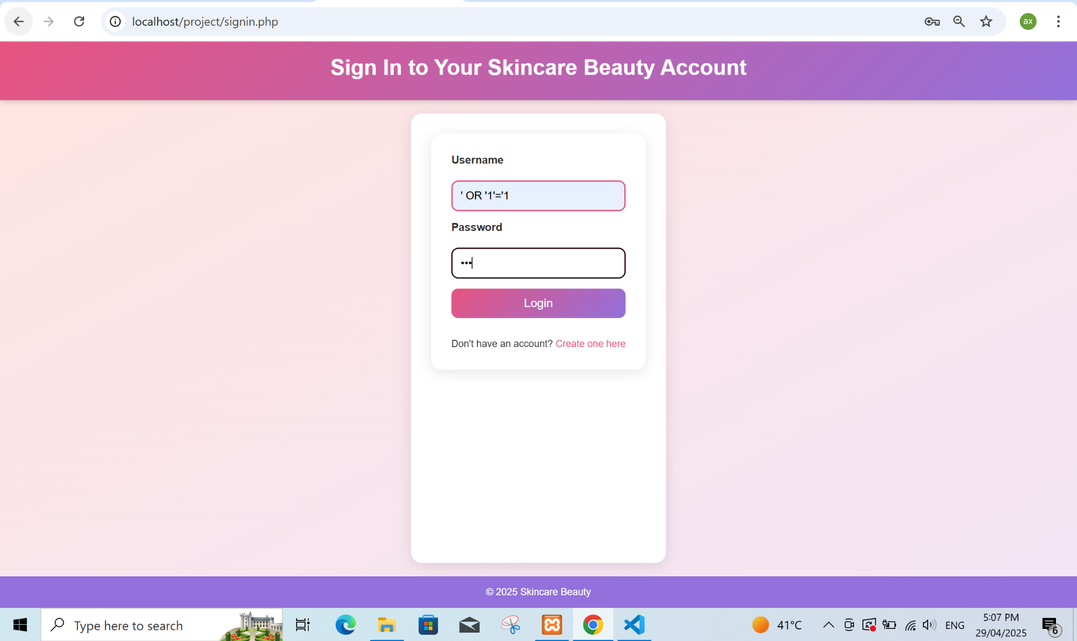

Figure 48. SQL Injection Attempt

The executed SQL query in this figure grants unauthorized system access to the attacker.

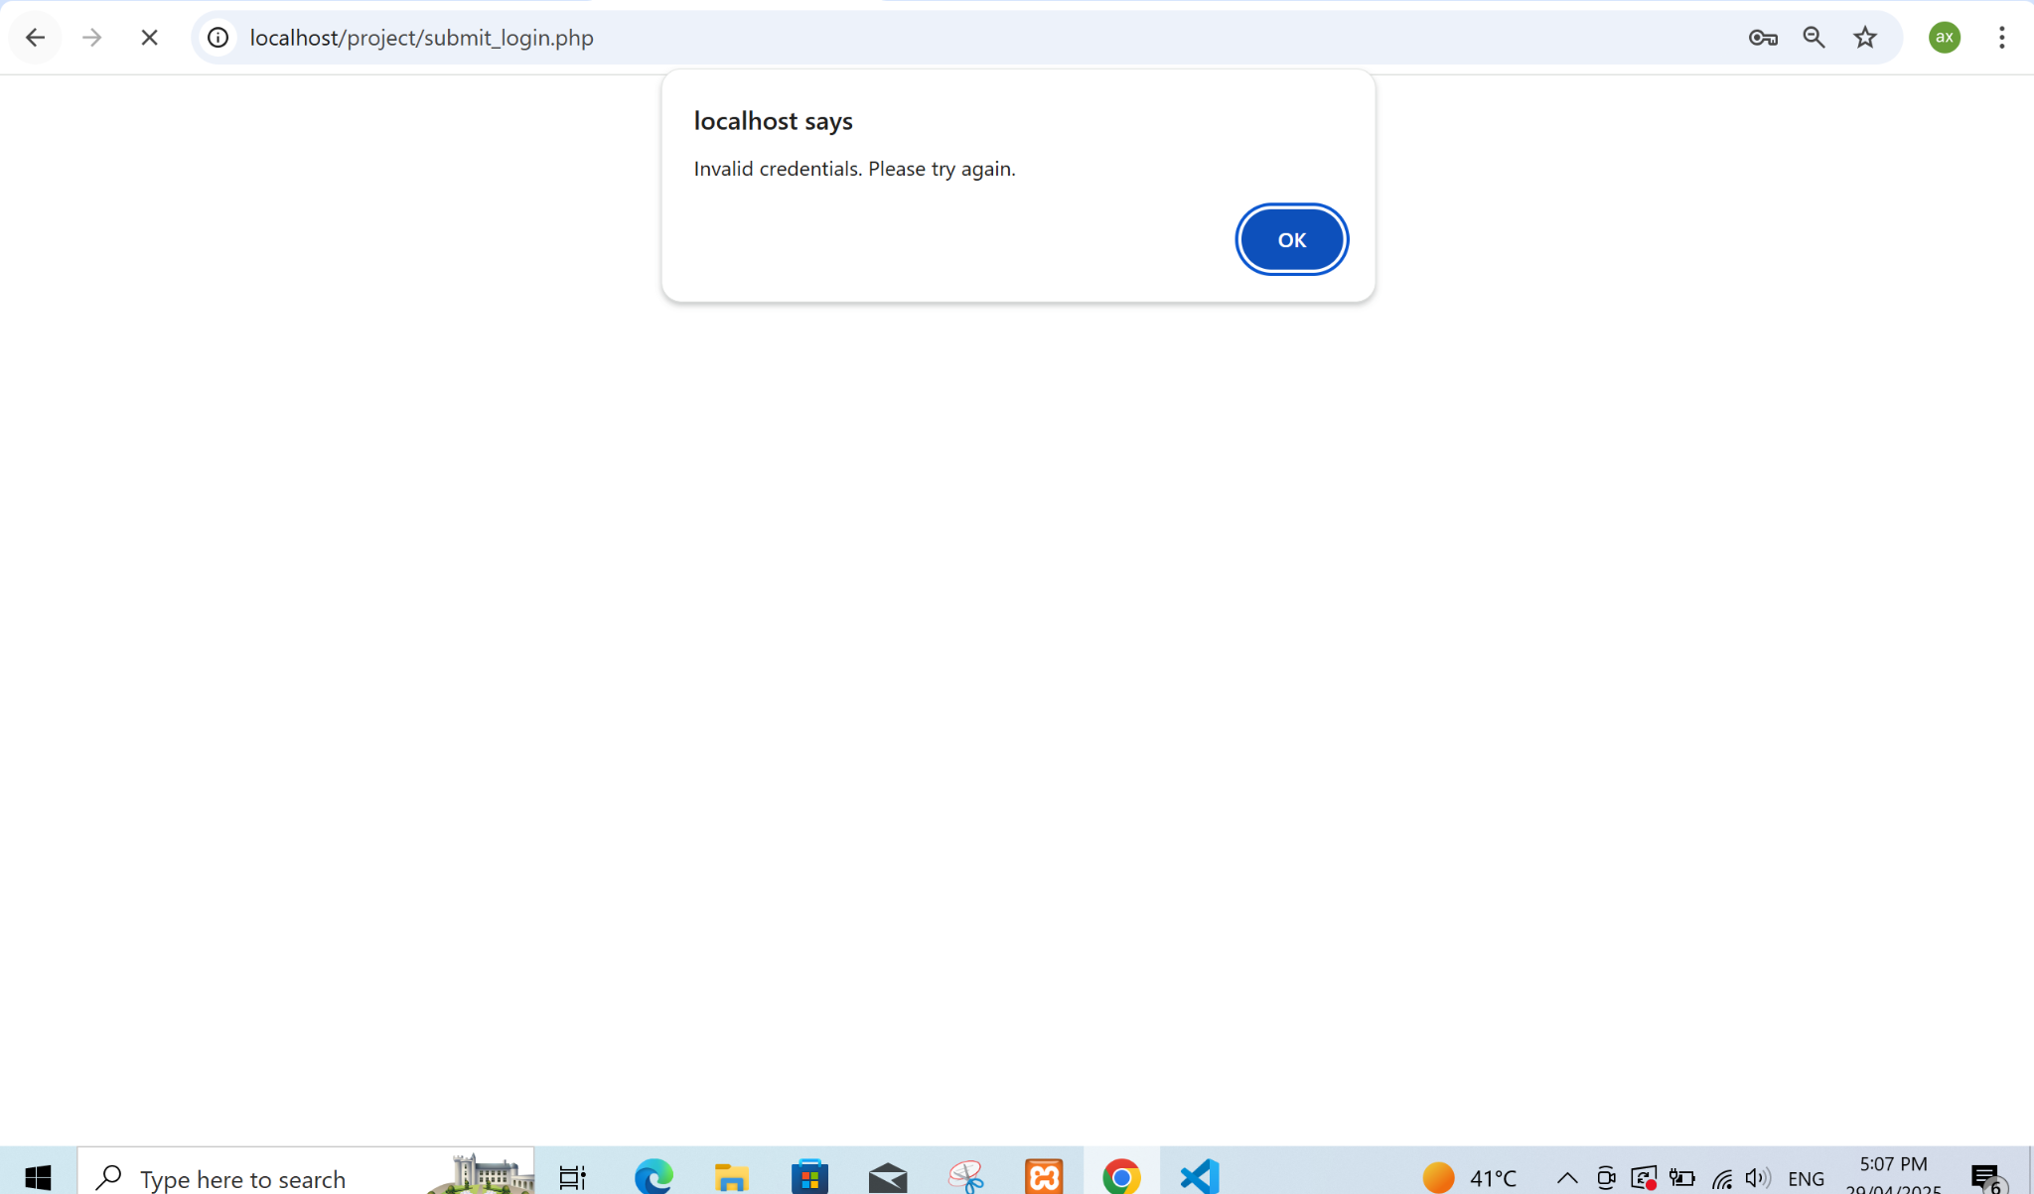

Figure 49. SQL Injection Outcome

# LFI (Local File Inclusion) Attack

## Explanation of LFI Vulnerability

Web applications allow attackers through LFI to include server files by permitting user inputs. The improper file inclusion vulnerability enables unauthorized access to expose all accessible system files as well as user-held documents. LFI exploitation occurs when attackers adjust file paths to exceed directory restrictions for obtaining server files which include both readable content and executable commands. Security measures of file paths require both validation and sanitization to protect administration systems and access should only be available to pre-approved safe files under proper authorization controls (Dizdar, 2025).

## Attack Demonstration

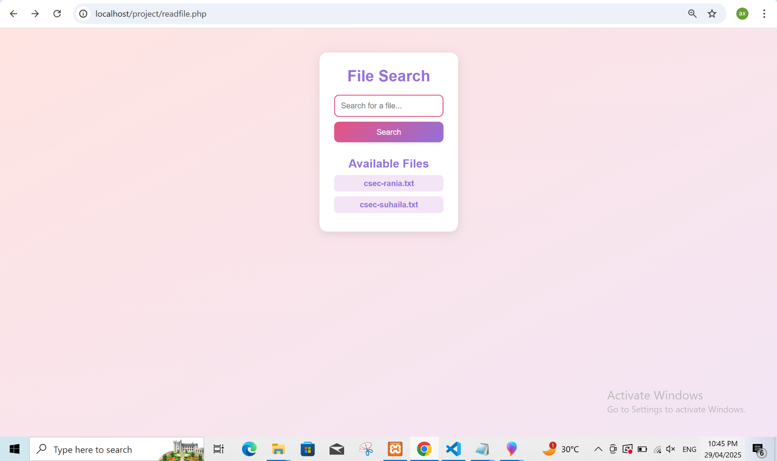

Figure 50. LFI Attack Demo

The Local File Inclusion (LFI) attack is introduced through this figure to display how unauthorized file access works by exploiting file inclusion functions beyond intended directories. we click on either the csec-rania.txt or csec-suhaila.txt where it will display the content of the file.

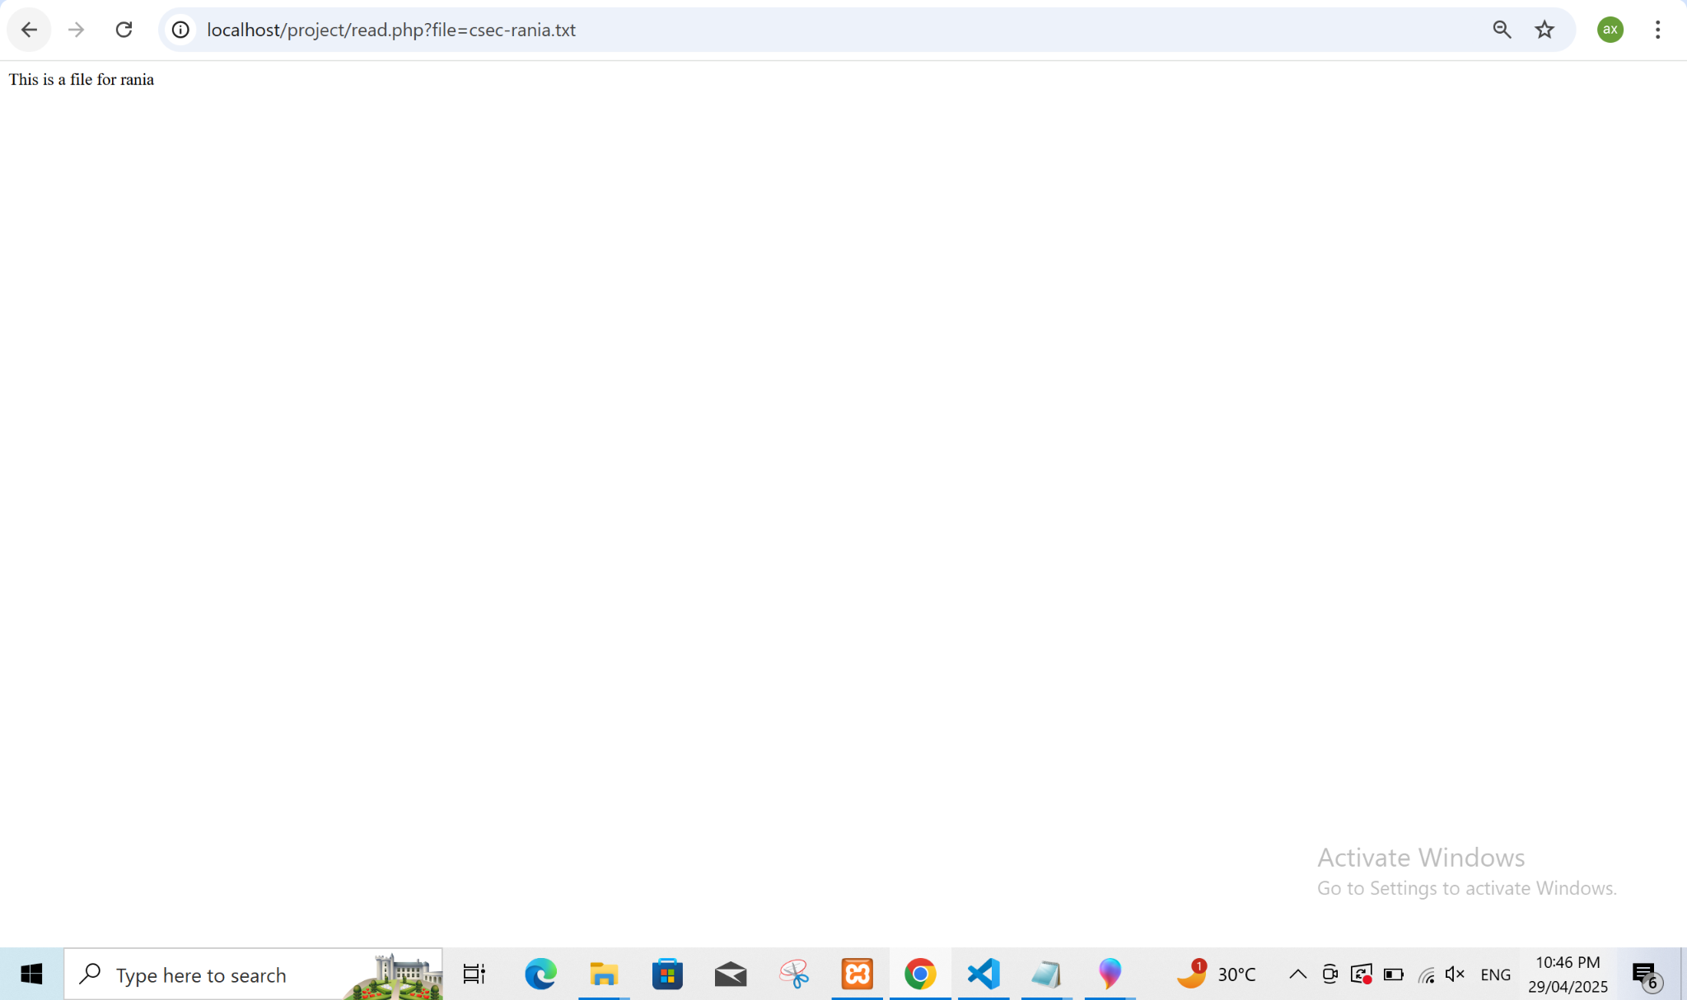

Figure 51. Accessing Files via LFI

The illustration presents an illustration of an LFI attack taking place. When users click csec-rania.txt or csec-suhaila.txt files it activates the attack which aims to integrate those files into the server response.

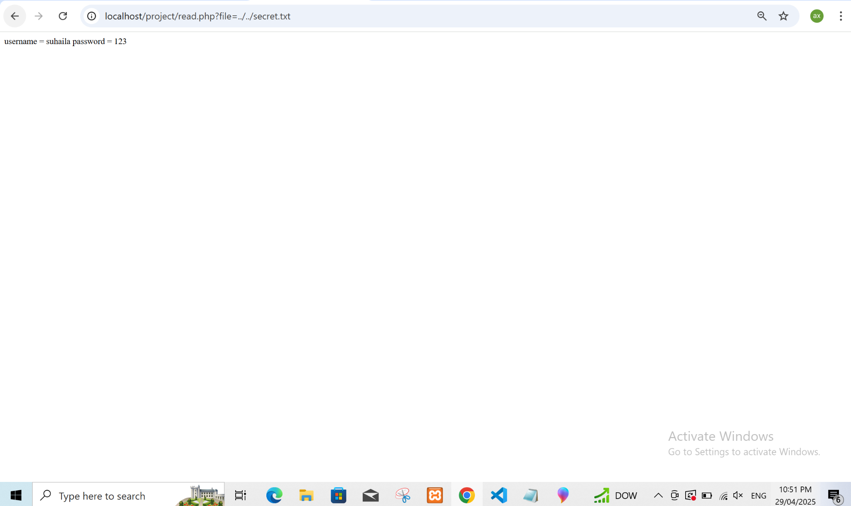

Figure 52. Read.php after LFI

This figure displays the read.php page after an LFI attack opens to reveal the content contained in the file. The intrusion allows the attacker to view sensitive data which is not located inside the pre-defined folder directory.

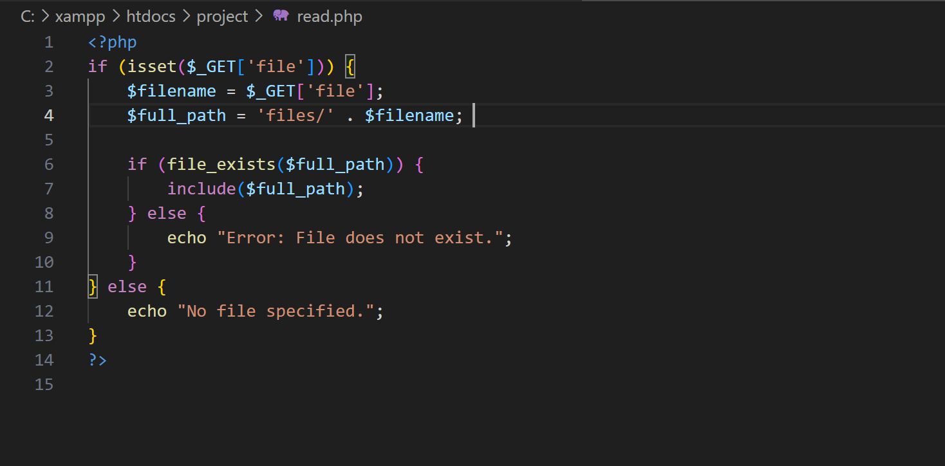

Figure 53. LFI Attack Code

The following code block presents the LFI attack implementation. The attack demonstration illustrates the method attackers use to modify file paths which allows them to reach sensitive files that are outside the approved folder boundaries.

## Mitigation

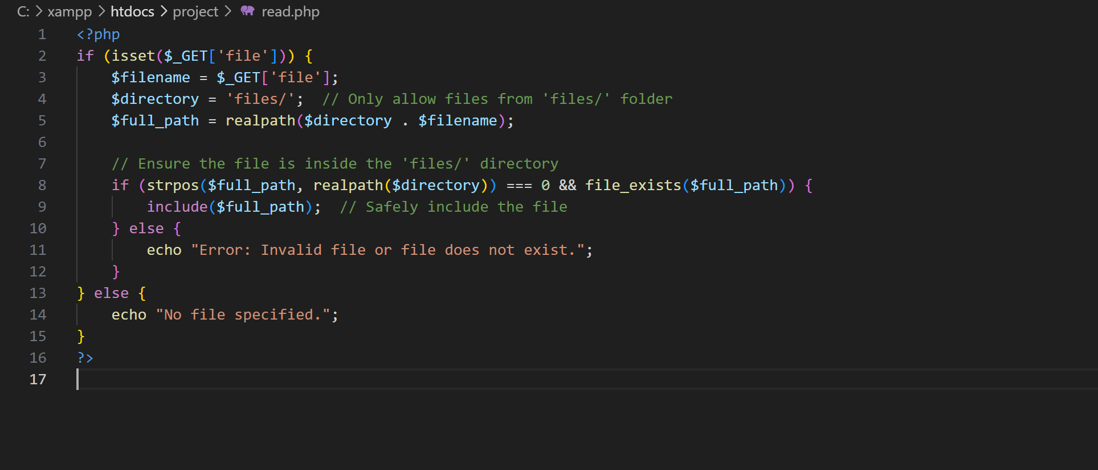

Figure 54. LFI Mitigation Code

The picture of the code demonstrates how to stop an LFI attack. Sanitizing file paths had solved the vulnerability by letting users access only approved directory files while blocking any unauthorized file inclusion attempts.

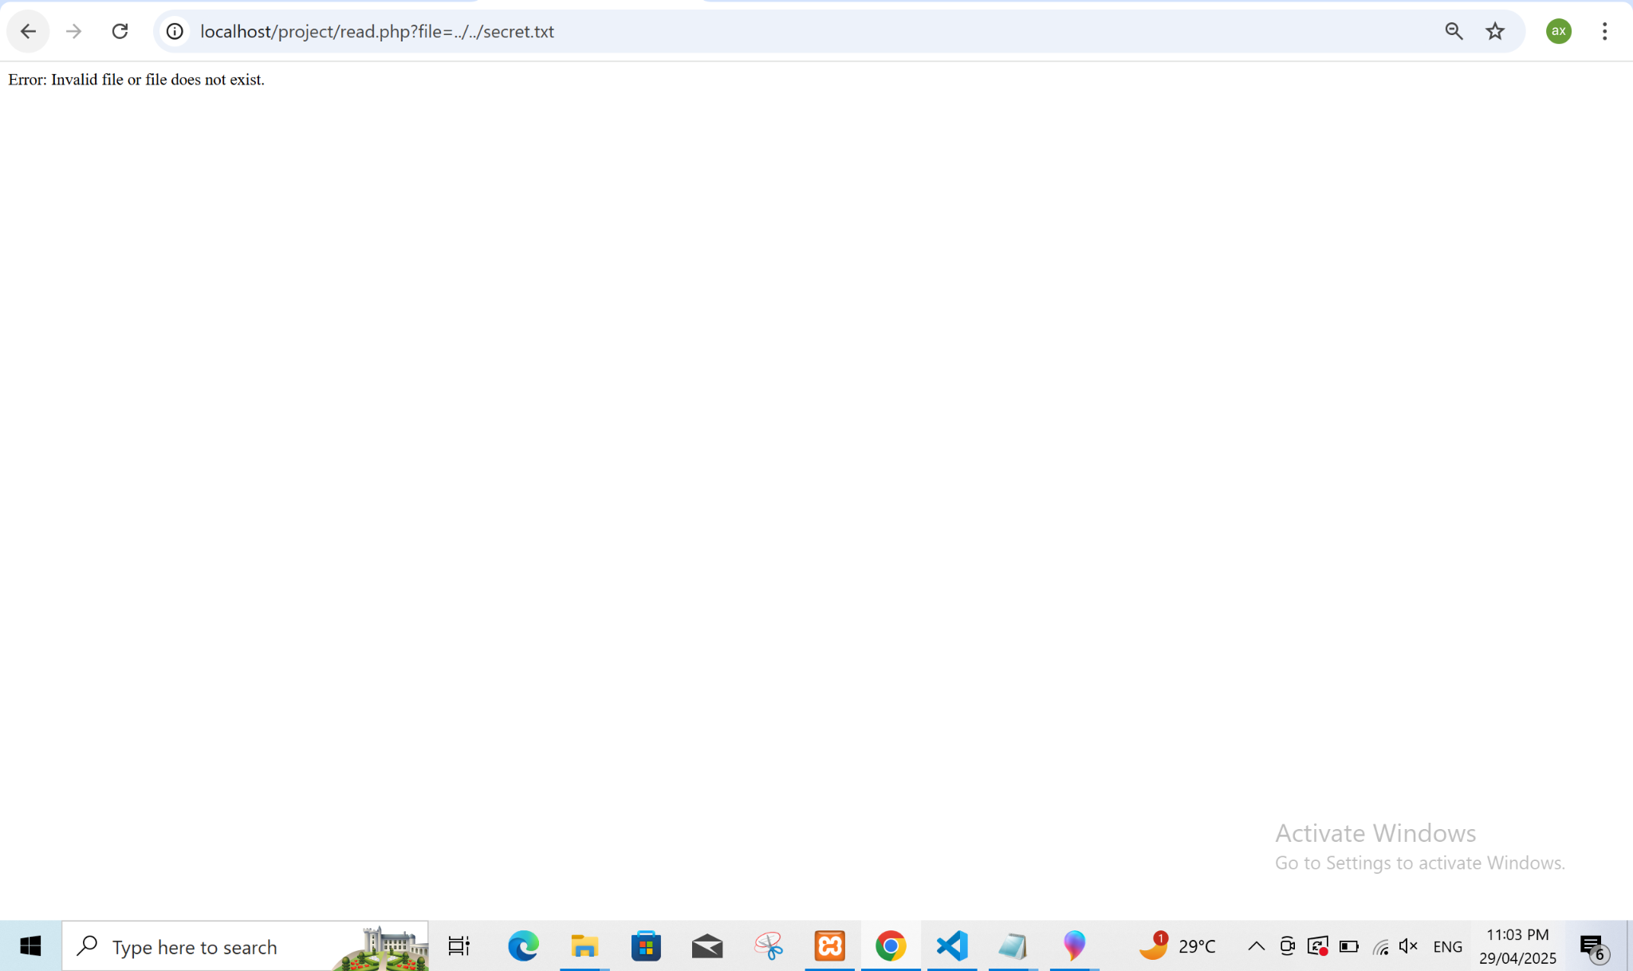

Figure 55. Post-LFI Mitigation Access

Next the diagram illustrates the LFI mitigation procedure in effect. The files folder accessibility improves after implementation because users now need to stay confined within its folder perimeter while blocked from accessing unauthorized materials.

# Brute-Force Attack

## Explanation of Brute-Force Vulnerability:

Through repetitive attempts to guess every possible login credential combination brute-force attacks carry out the password guessing process. The technique achieves success in cracking weak or basic passwords. Automated brute-force tools succeed with their attacks because of weak passwords and the current account lockout systems in place. Preventing unauthorized access demands users to build strong passwords in addition to enabling account lockout features that require extended identity verification through MFA protocols (Frontegg, 2025).

## Attack Demonstration

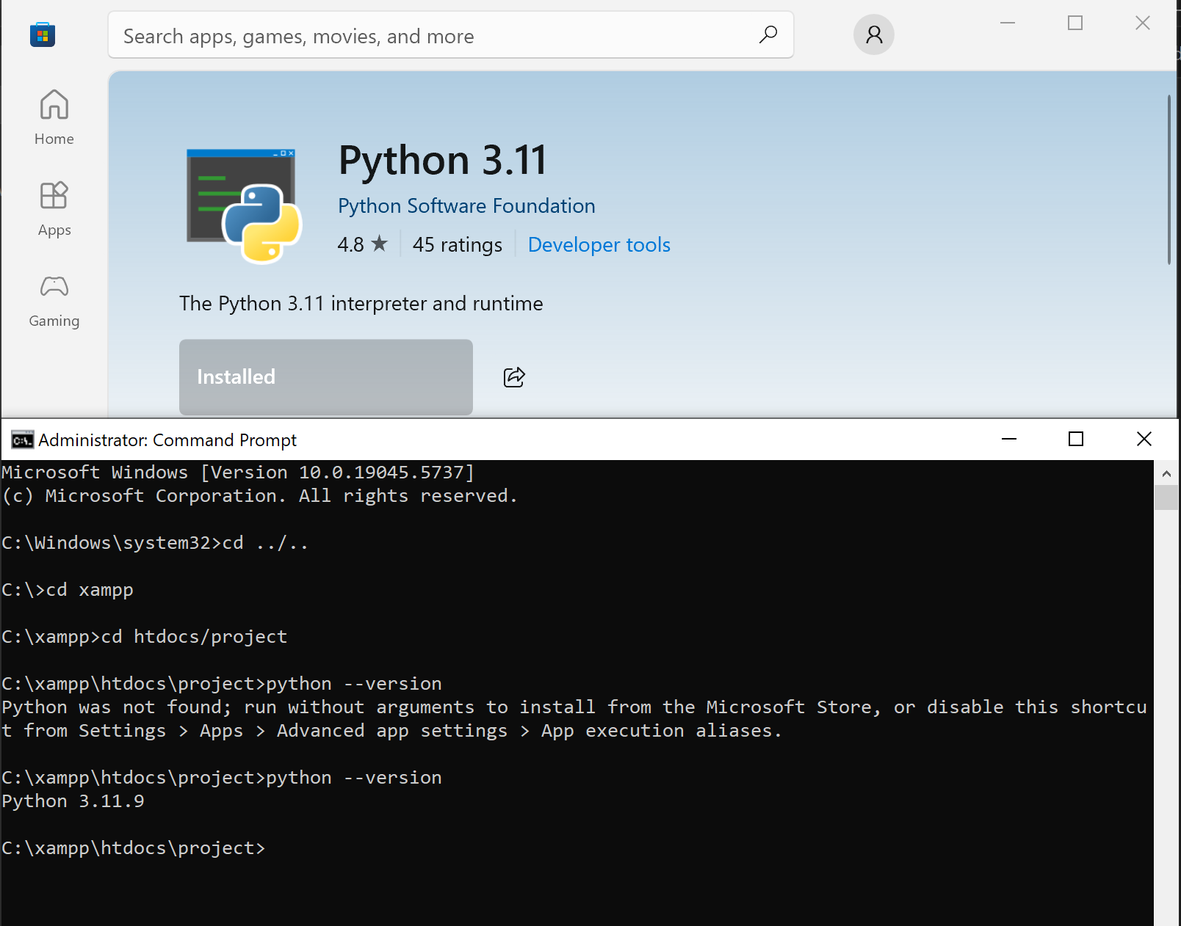

Figure 56. Brute-Force Python Setup

The representation of Brute-Force attack vulnerability exists in this diagram. The explanation shows how attackers attempt numerous username-password pairs against user accounts to succeed in unauthorized access.

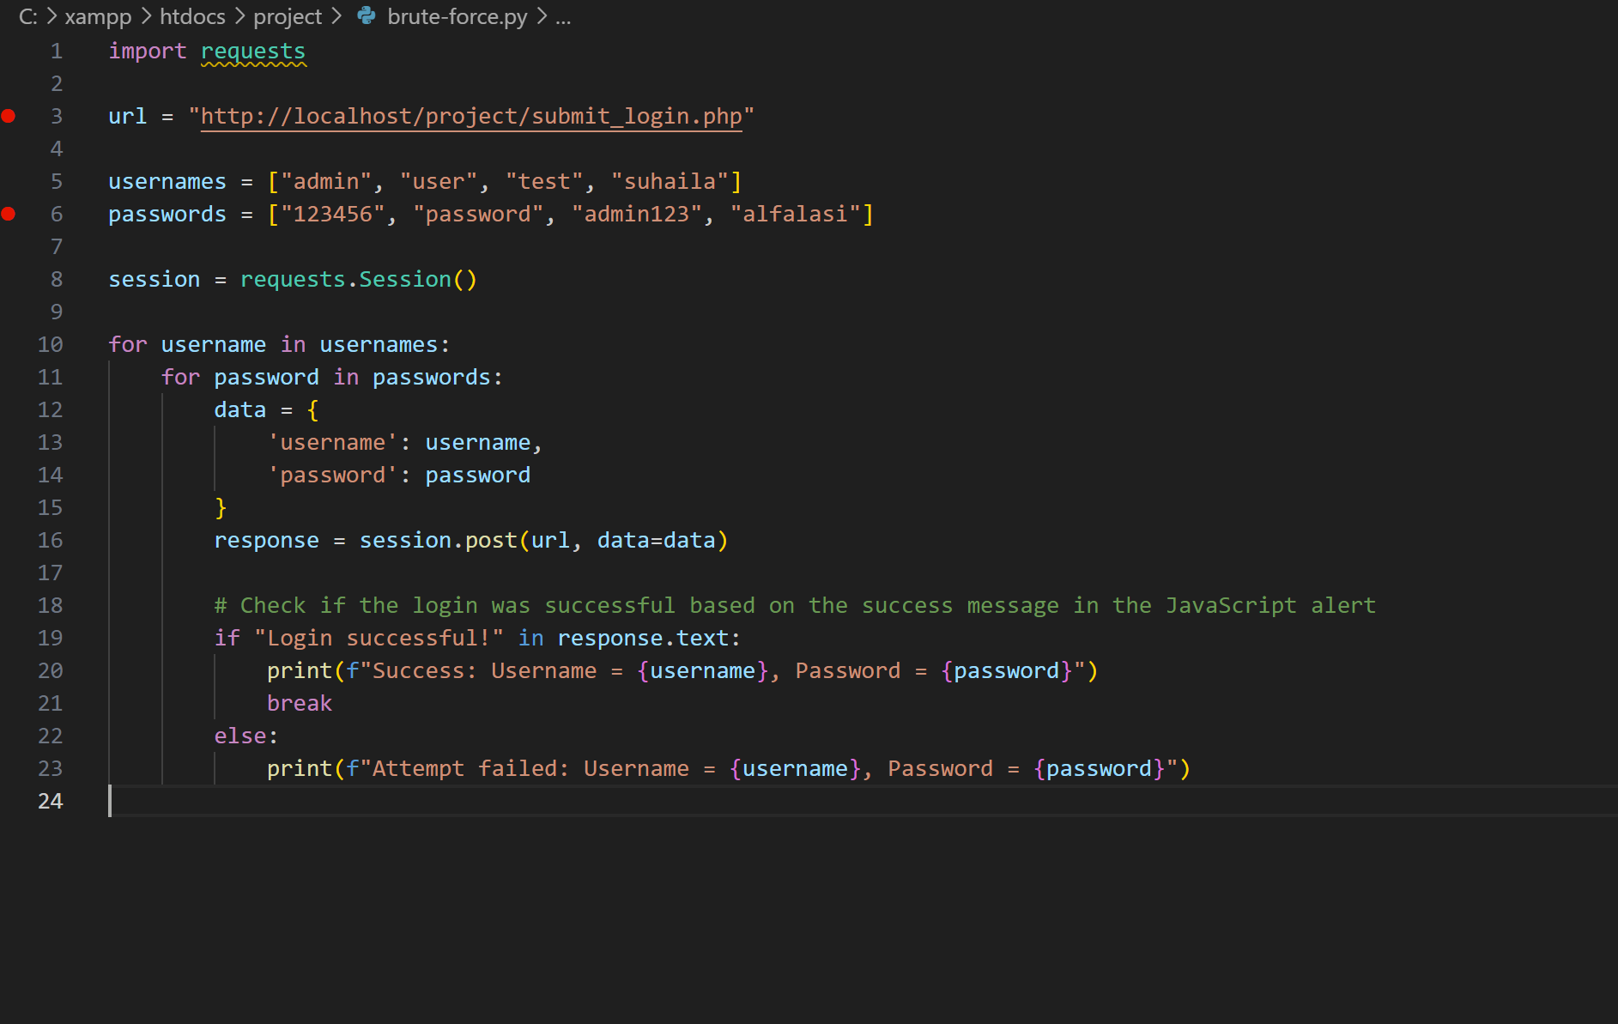

Figure 57. Installing Requests Library

The illustration in Figure 57 shows how to set up requests library within Python. The requests library functions as a toolkit to perform HTTP requests for sending fake login attempts to the website.

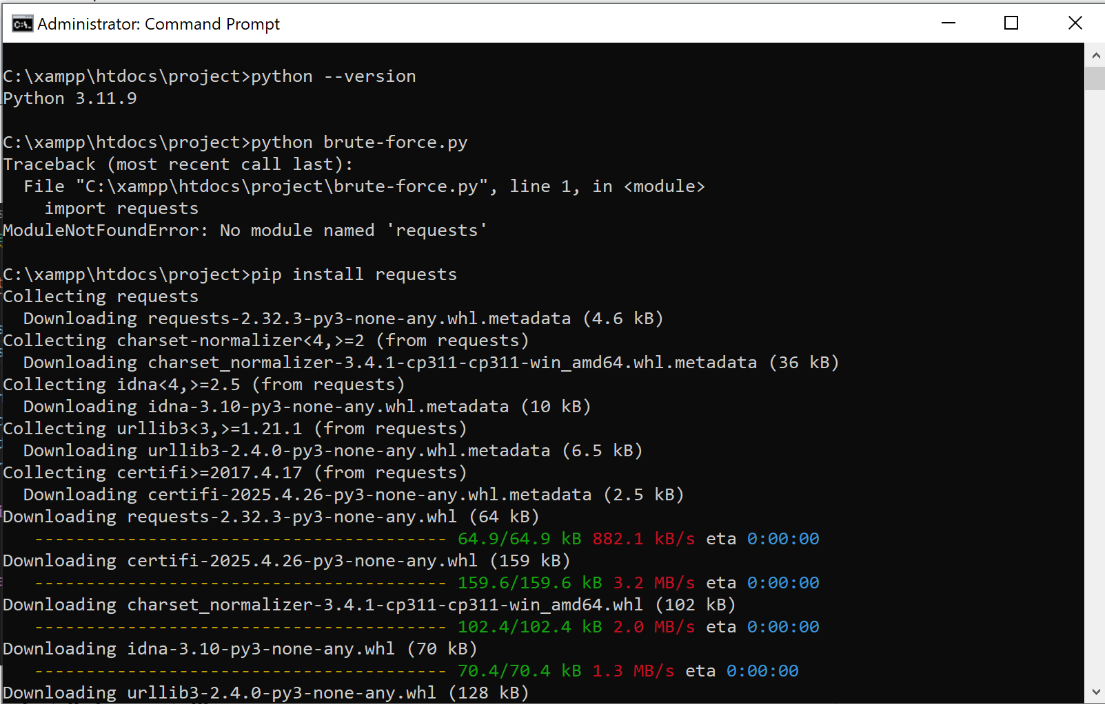

Figure 58. Brute-Force Module Installation

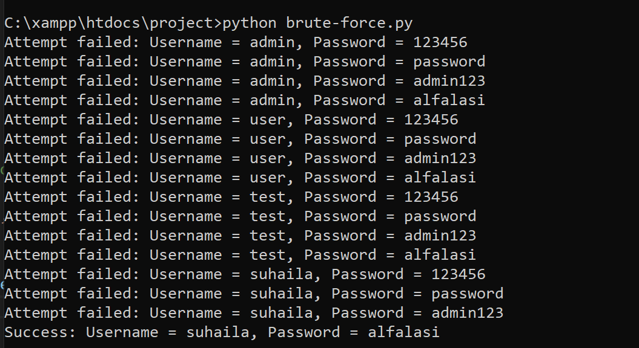

Figure 59. Brute-Force Execution Output

The brute-force script execution reveals the number of unsuccessful login attempts and finally leads to success after multiple attempts demonstrating the path attackers need to follow.

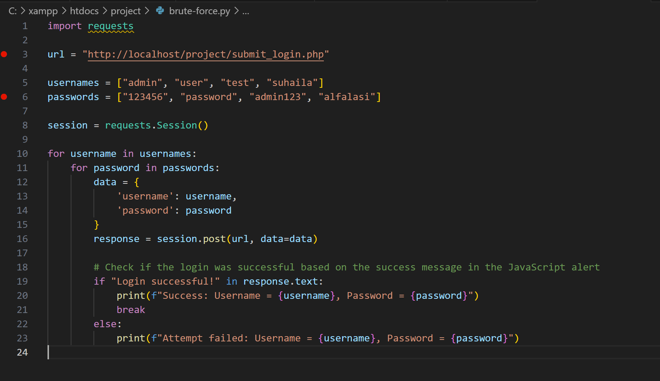

Figure 60. Brute-Force Attempt Code

The figure most likely represents the portion of the brute-force script from number lines of 16 -23 which executes POST requests containing various username and password combinations for login verification.

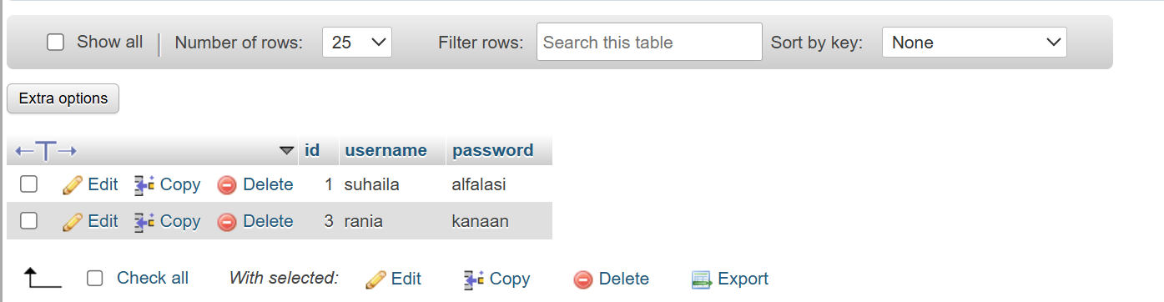

Figure 61. phpMyAdmin User Info

Through the phpmyadmin interface the attacker differentiates which usernames and passwords can be targeted through a brute-force attack.

## Mitigation

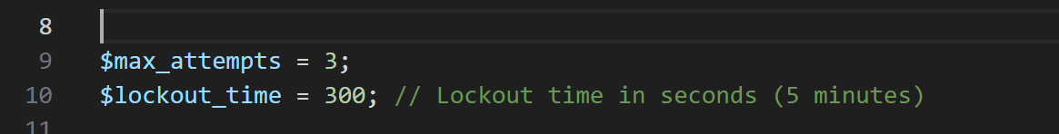

Figure 62. Brute-Force Mitigation Code

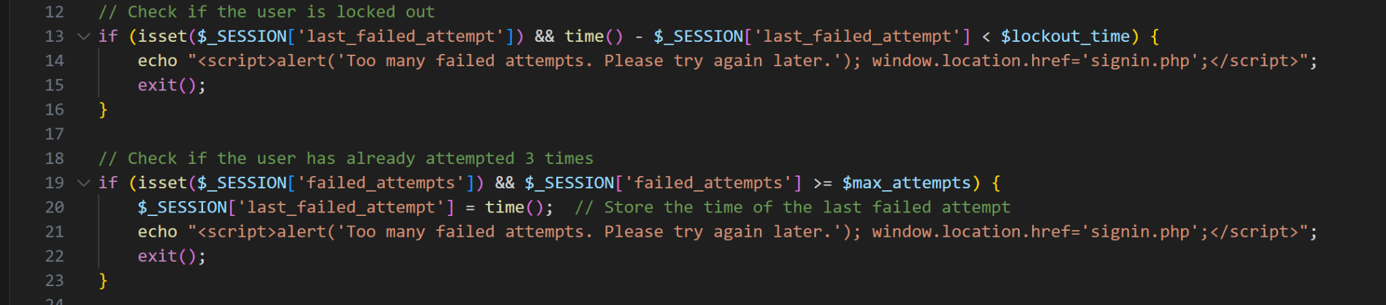

Figure 63. Brute-Force After Mitigation

The security measure for defending against brute-force attacks is presented within this illustration. Account lockout and login attempt limitation functions as shown in this figure prevent successful brute-force attacks.

The updated code appears in Figure 61 showing how the applied measures stop brute-force attacks from occurring. The system implements a feature that registers login attempts and locks users out after meeting a specified number of wrong attempts.

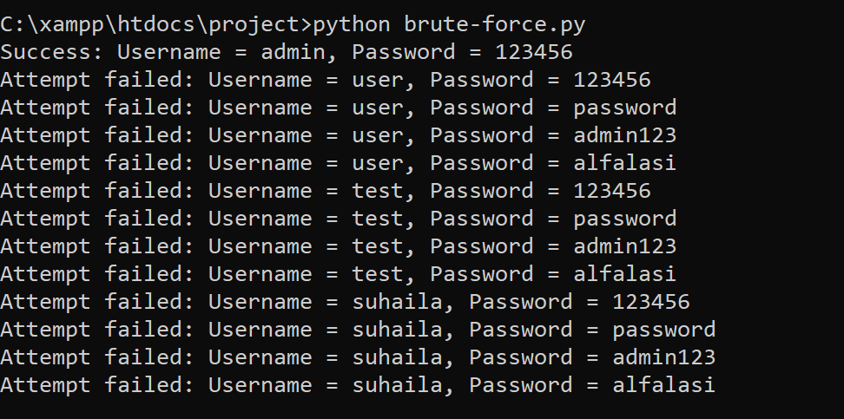

Figure 64. Brute-Force Failure

The system implements access blocking following three consecutive failed login attempts according to this result figure after applying the protection measures.

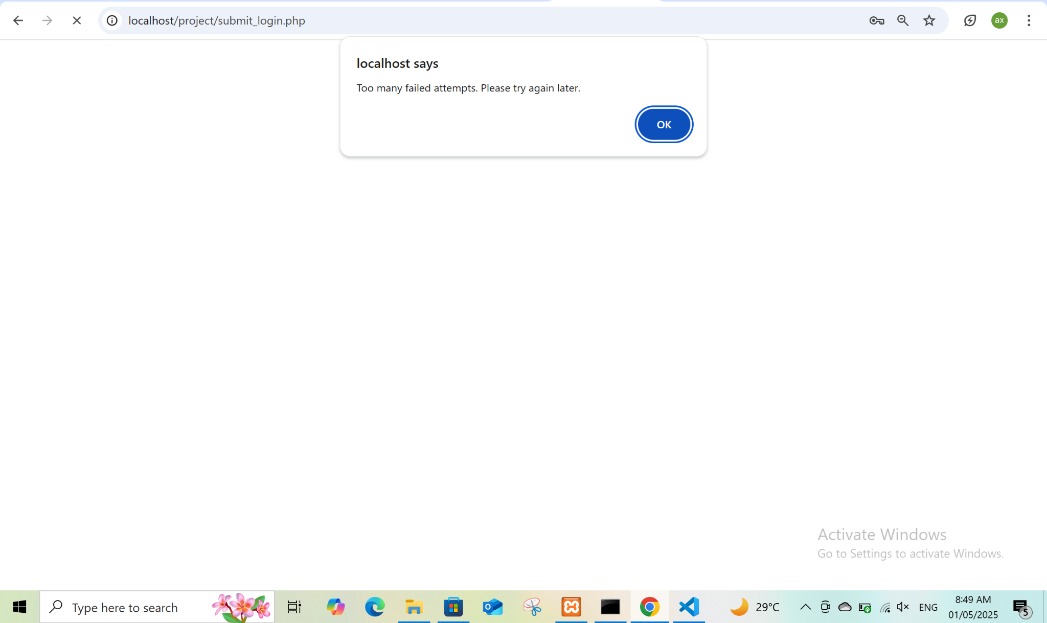

Figure 65. Brute-Force Web Attempt

Attacks targeting the web interface through multiple password attempts appear in this figure because the defense system is blocking the offender.

# IDOR (Insecure Direct Object References) Attack

## Explanation of IDOR Vulnerability

Failure to use proper access controls allows attackers to see application records and files and URL addresses thus triggering an IDOR situation. Attackers exploit implemented vulnerability through URL identification values to obtain unauthorized system access. The weakness enables attackers to bypass security procedures that control user access. User input validation together with resource authorization checks remain essential for defense since this combination validates users possess valid access rights for targeted resources (Amissah & Bentil, 2024).

## Attack Demonstration

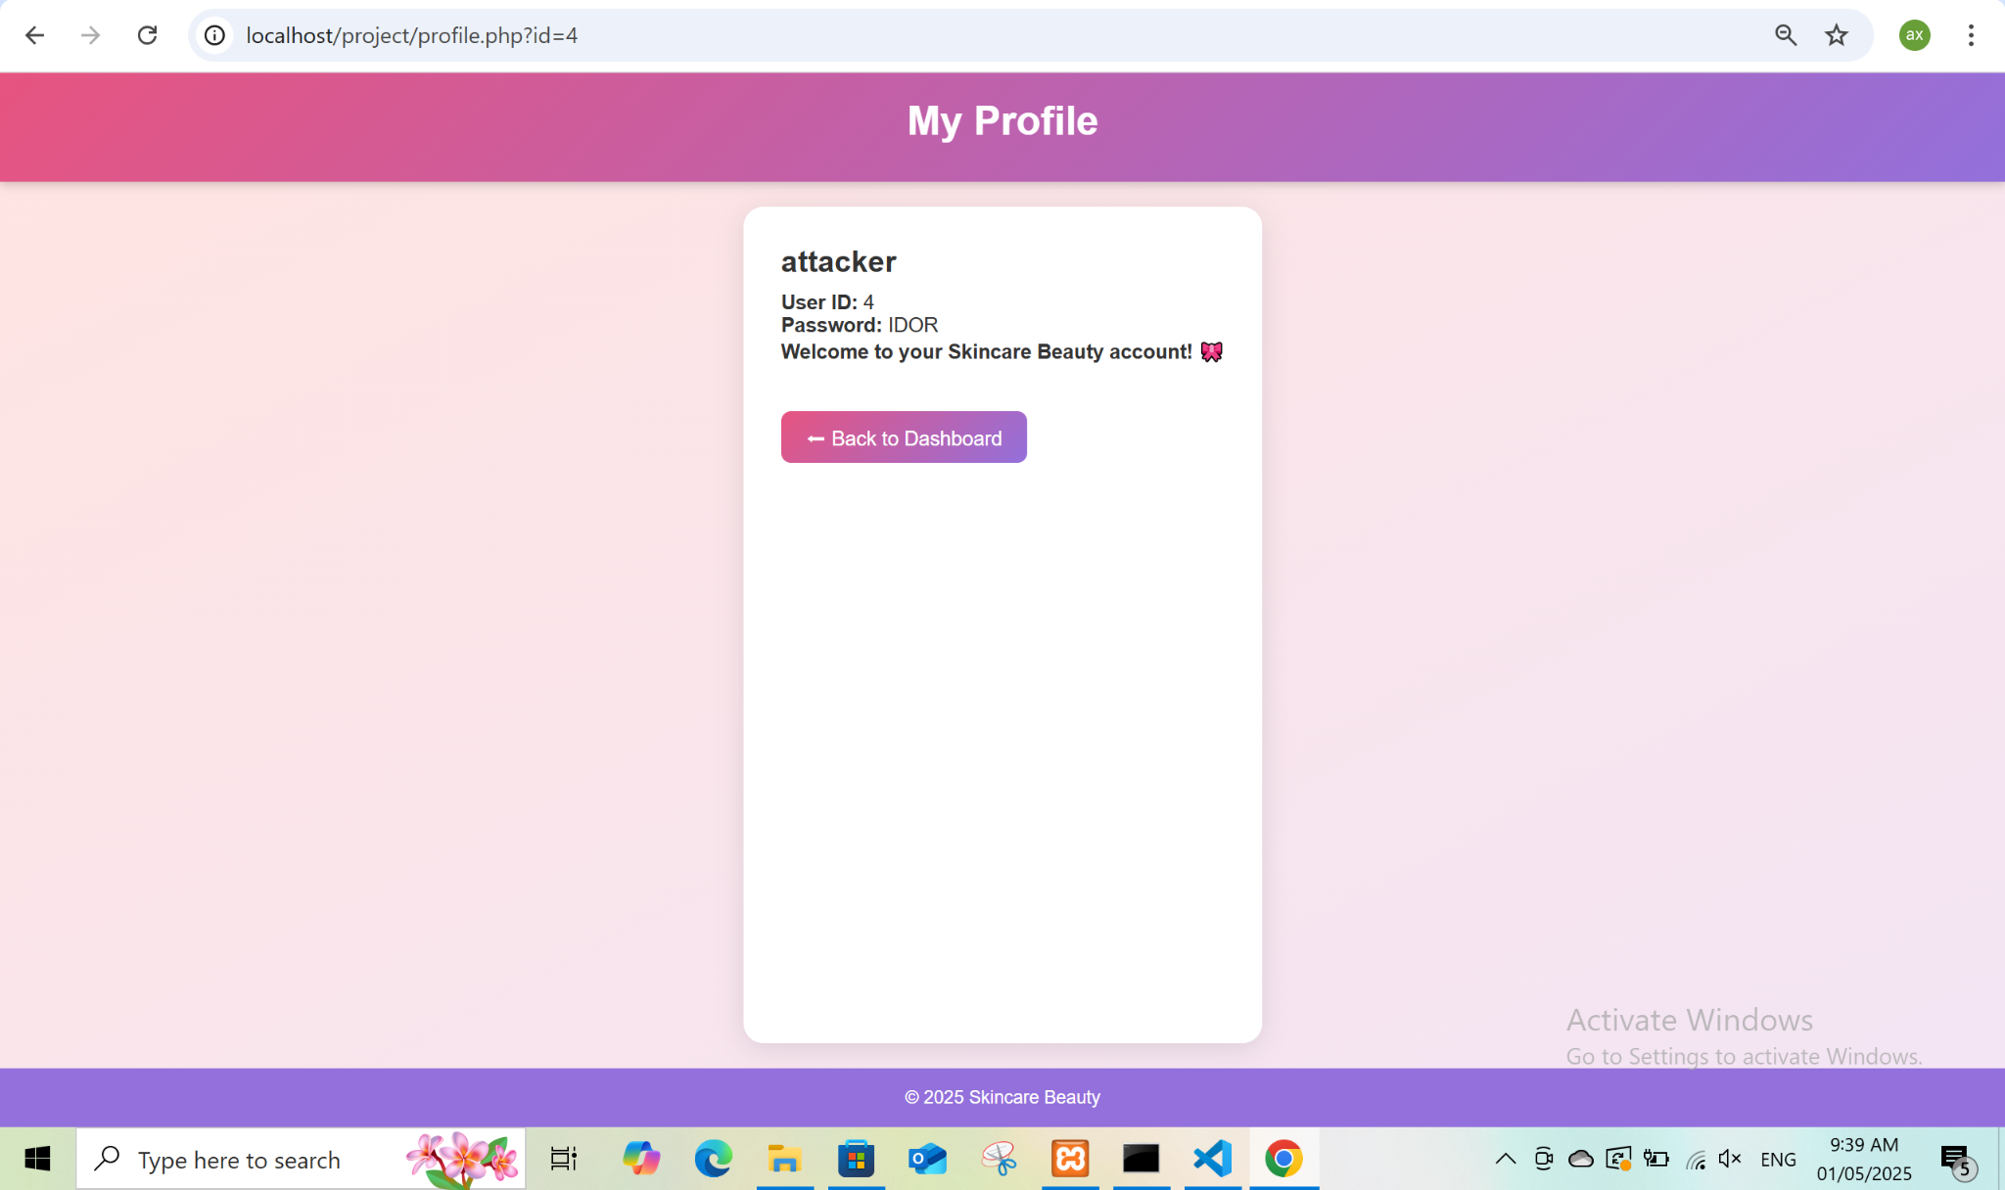

Figure 66. IDOR Attack

The Insecure Direct Object References (IDOR) vulnerability is presented in Figure 65. The text explains that cyber criminals take advantage of this flaw by modifying specific URL parameters to acquire inappropriate objects and unauthorized data.

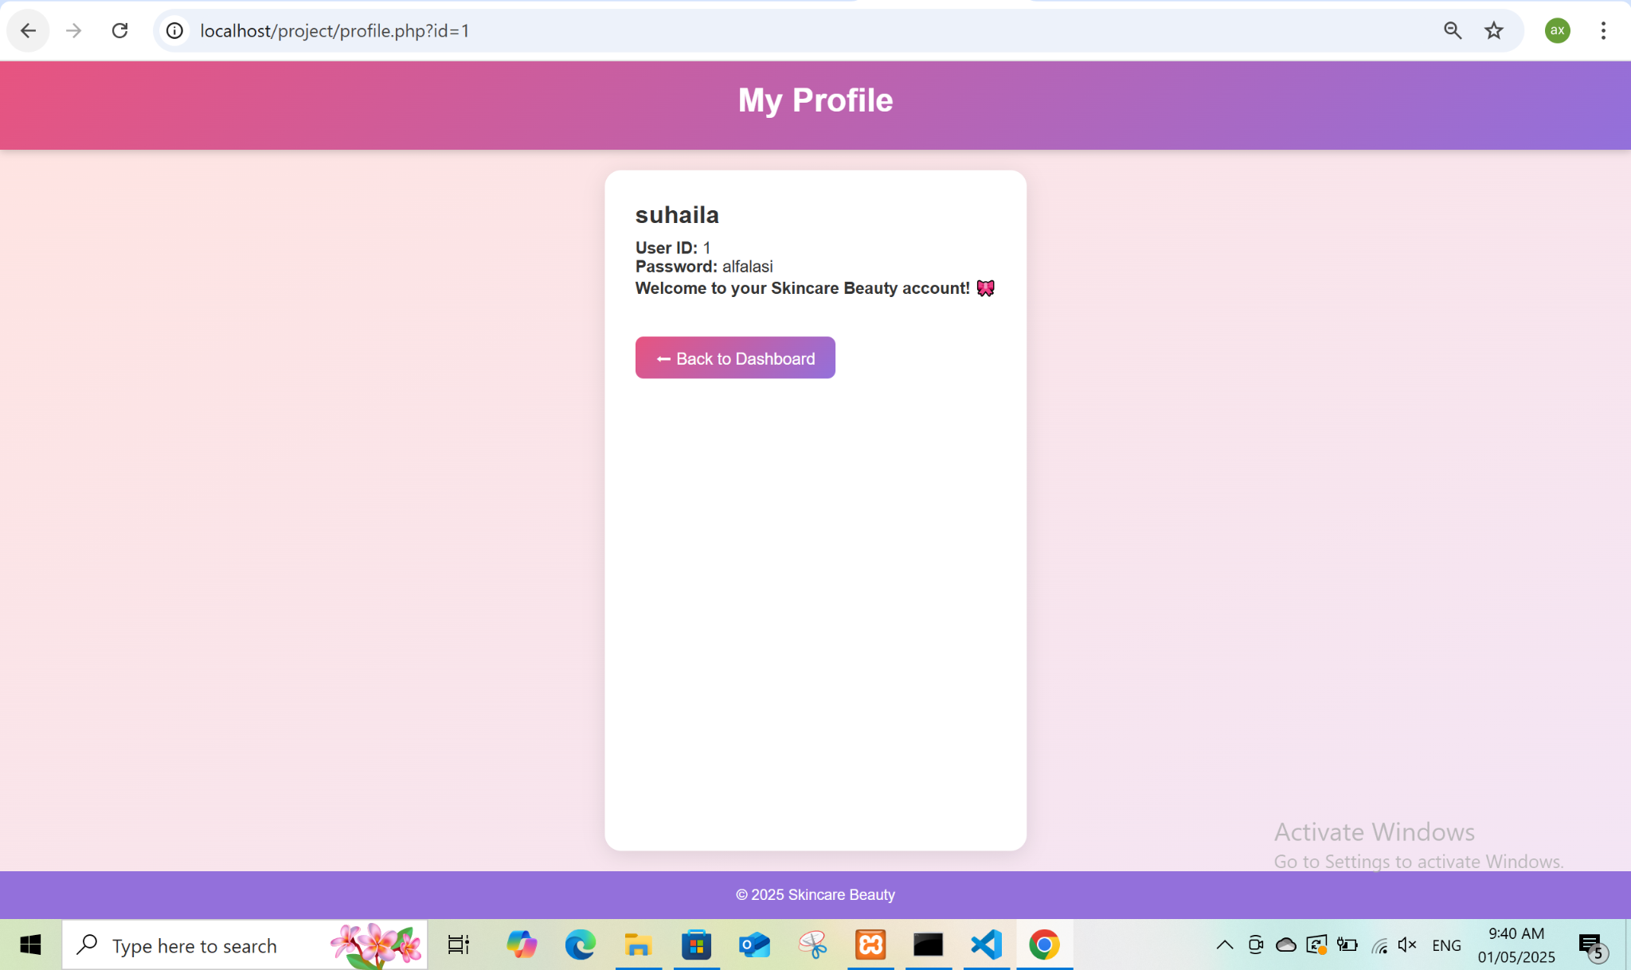

Figure 67. IDOR Attack Demo

During the demonstration this figure displays how an attacker modifies the URL parameter id=4 into id=1 thereby unauthorized access to other user profiles.

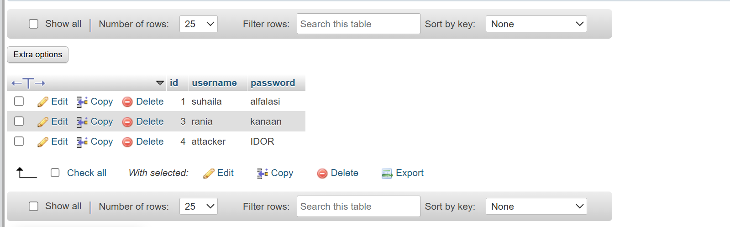

Figure 68. phpMyAdmin IDOR Exploit

An attacker uses the phpmyadmin interface as illustrated in this figure to manipulate IDs for database access of different user data.

## Mitigation

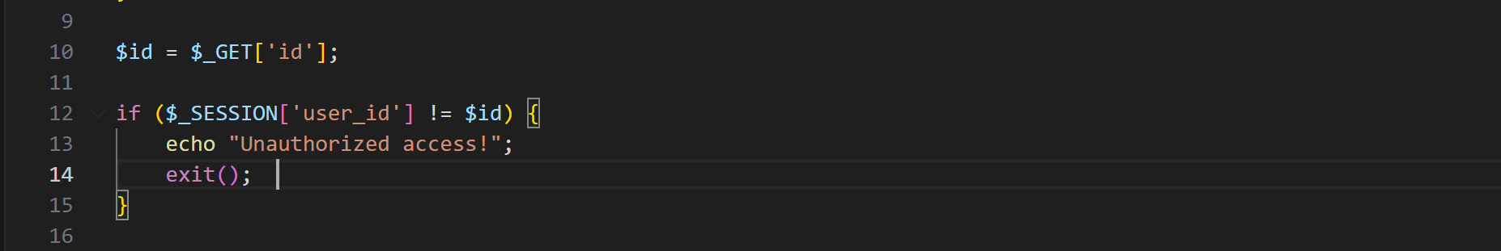

Figure 69. IDOR Mitigation Code

A solution against the IDOR attack is detailed in this depiction. The solution should include proper access control checks that restrict users to view only their own data information.

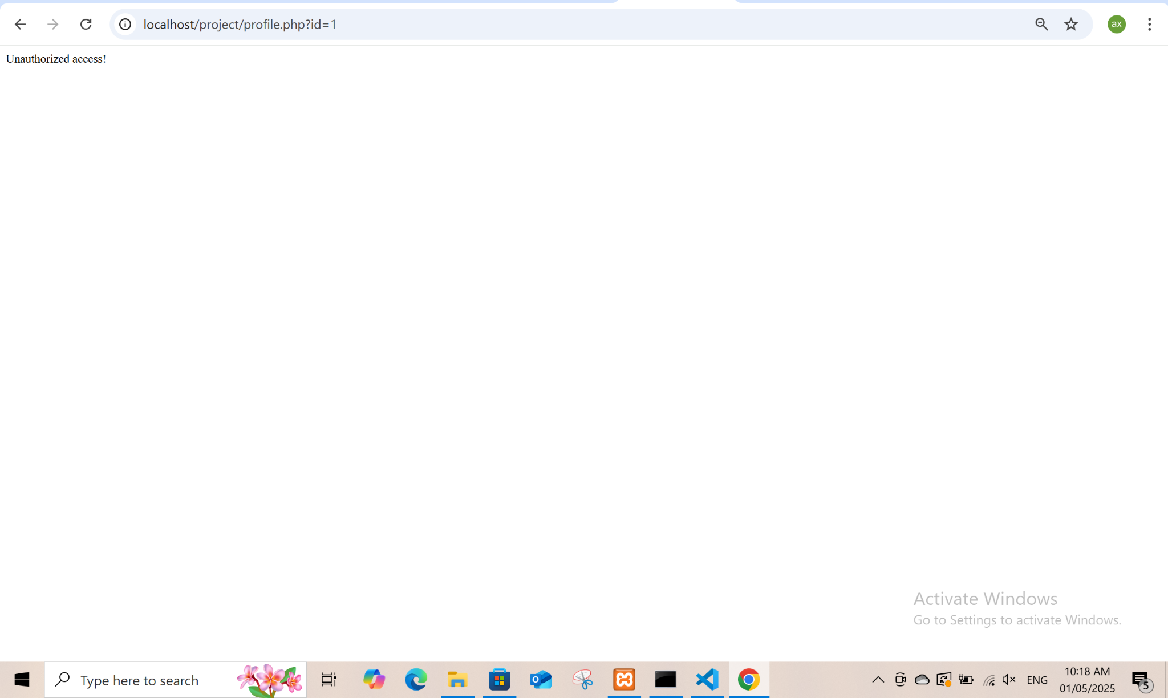

Figure 70. IDOR After Mitigation

The applied IDOR mitigation produces this result. System access restriction occurs when the attacker modifies the id parameter value to 1 which indicates successful implementation of the mitigation.

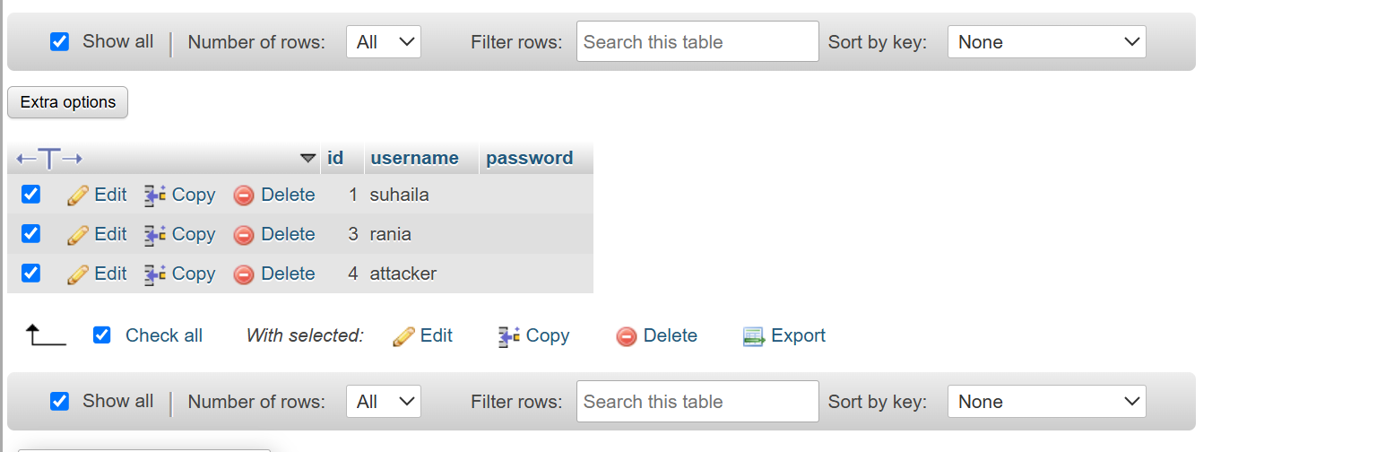Figure 71. Password Exposure Issue

The figure demonstrates how passwords must remain undisclosed both in URLs and databases. The figure presents the proper technique for password security through hashed methods.

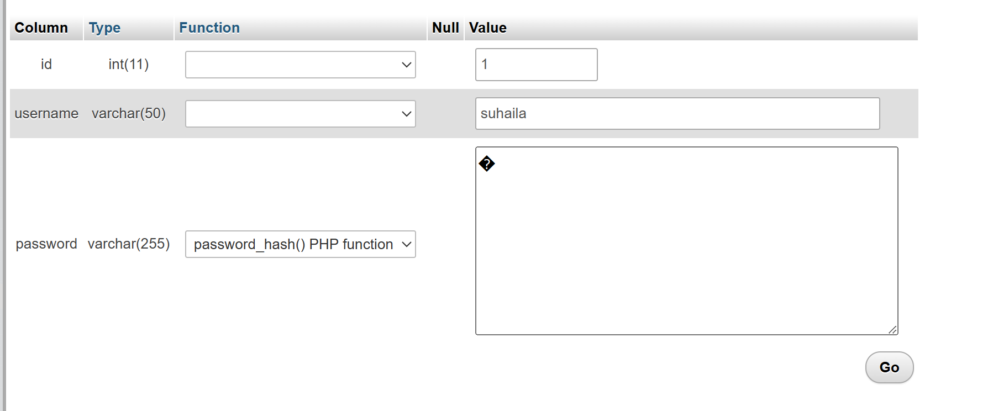

Figure 72. Password Hashing Process

Figure 72 presents the steps for hashing passwords that occur within the phpmyadmin dashboard. The user data editing interface provides functionality to hash passwords which protects their access by unauthorized parties.

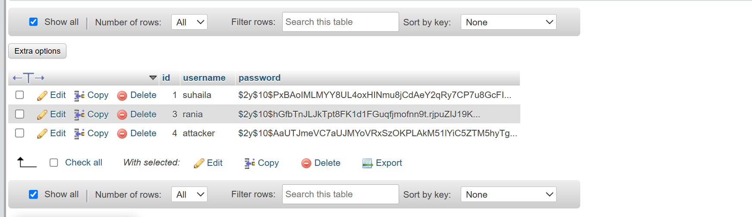

Figure 73. Hashed Passwords View

A successful implementation of hashing techniques results in the output presented in this figure that applies encryption to all passwords in the database. The security measure provides database defense in case attackers manage to access the database because passwords are kept secure.

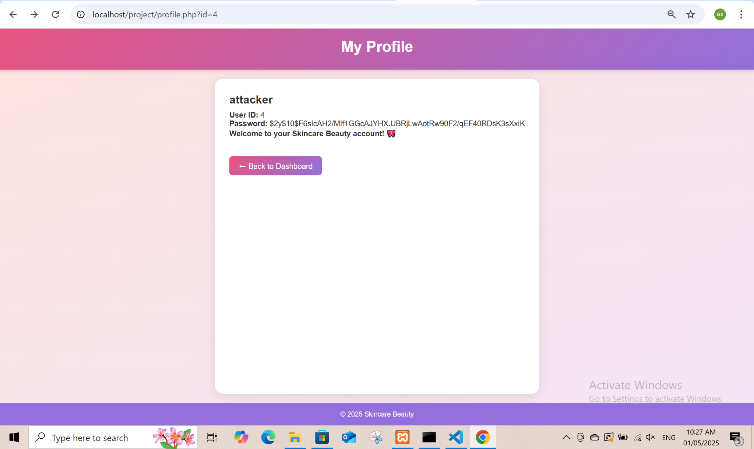

Figure 74. Hashed Passwords on Website

Users have access to multiple hashed passwords through this figure because it displays them on the site to provide secure transmission and storage of credentials.

The closure of the process displays the endpoint which contains both mitigation mechanisms and password hashing algorithms while implementing proper access control measures.

# Conclusion

The project achieved extensive web application security assessment results from realistic vulnerability tests of Persistent XSS and SQL Injection attacks alongside LFI as well Brute-Force and IDOR vulnerabilities. The built-in security risks of our purposely unsafe website increased our capability to find and effectively combatAttackers’ typical security vulnerabilities. Direct involvement with the project allowed us to experience the multiple significant risks that stem from insecure systems where unauthorized access combined with data loss and system breach events and financial setbacks occur. The work relied heavily on secure web development practices to succeed since it required both validated inputs and protected authentication and managed sessions.

Prevailing vulnerabilities became less dangerous when developers integrated input sanitation practices and parameterized SQL queries and password hashing and access control prevention strategies. The implemented security systems provided both vulnerability reduction and taught necessary proactive security methods for web development. This project enabled our team to grasp better how attackers exploit weaknesses so developers can create defense strategies to stop the attacks.

The research project revealed the high complexity of authentic web application security operations. The development of secure standards should occur simultaneously between developers and cybersecurity personnel during the initial stages of web creation. Developers now have access to vital information that helps them improve data protection alongside system integrity to develop robust web applications. Students gaining essential capabilities through education will allow them to develop secure system creation abilities and identify vulnerabilities and respond to threats in the growing cybersecurity field.

# References

Demilie, W. B., & Deriba, F. G. (2022). Detection and prevention of SQLI attacks and developing compressive framework using machine learning and hybrid techniques. *Journal of Big Data*, *9*(1). <https://doi.org/10.1186/s40537-022-00678-0>

Dizdar, A. (2025). Local file Inclusion: understanding and preventing attacks. *Bright Security*. https://www.brightsec.com/blog/local-file-inclusion-lfi/

Tadhani, J. R., Vekariya, V., Sorathiya, V., Alshathri, S., & El-Shafai, W. (2024). Securing web applications against XSS and SQLi attacks using a novel deep learning approach. *Scientific Reports*, *14*(1). <https://doi.org/10.1038/s41598-023-48845-4>

Amissah, E., & Bentil, F. (2024). Exposing insecure Direct Object reference (IDOR) vulnerabilities in academic publication platforms: a case study. In International Journal of Engineering Research, *International Journal of Engineering Research*(Vols. 13–13, Issue 08, pp. 088–088) [Journal-article]. <https://www.researchgate.net/publication/383740278>

Frontegg. (2025). *Brute Force Attacks Explained: Types, techniques, and prevention | Frontegg*. Frontegg. <https://frontegg.com/blog/brute-force-attacks>

# Appendices

Style.css

/* Global Reset */

* {

margin: 0;

padding: 0;

box-sizing: border-box;

}

body {

font-family: 'Poppins', sans-serif;

background: linear-gradient(to bottom right, #ffe4e1, #f3e5f5); /* soft pink to purple */

min-height: 100vh;

color: #333;

display: flex;

flex-direction: column;

}

header {

background: linear-gradient(135deg, #e75480, #9370db); /* pink to purple */

padding: 20px;

text-align: center;

color: white;

box-shadow: 0 2px 8px rgba(0, 0, 0, 0.2);

}

h1, h2 {

margin-bottom: 10px;

}

nav {

margin-top: 10px;

}

nav a {

margin: 0 10px;

text-decoration: none;

color: #fff;

font-weight: bold;

font-size: 1.1em;

}

nav a:hover {

text-decoration: underline;

}

main {

flex: 1;

padding: 30px;

max-width: 800px;

margin: 20px auto;

background: #fff;

border-radius: 16px;

box-shadow: 0 4px 20px rgba(0,0,0,0.1);

}

form {

display: flex;

flex-direction: column;

gap: 15px;

margin-top: 20px;

}

input[type="text"], input[type="password"], textarea {

padding: 12px;

border: 2px solid #e75480;

border-radius: 10px;

font-size: 1em;

}

button {

padding: 12px;

background: linear-gradient(135deg, #e75480, #9370db);

color: white;

border: none;

border-radius: 10px;

font-size: 1.1em;

cursor: pointer;

transition: 0.3s;

}

button:hover {

background: linear-gradient(135deg, #9370db, #e75480);

transform: scale(1.05);

}

textarea {

resize: vertical;

}

footer {

background: #9370db;

color: white;

text-align: center;

padding: 15px;

font-size: 0.9em;

}

.blog-posts {

margin-top: 30px;

}

.blog-post {

background: #ffe4e1;

padding: 20px;

border-radius: 12px;

margin-bottom: 20px;

box-shadow: 0 2px 10px rgba(0,0,0,0.1);

}

.blog-post h2 {

color: #9370db;

}

.banner {

width: 100%;

border-radius: 16px;

margin-bottom: 20px;

object-fit: cover;

max-height: 300px;

}

img {

width: 100%;

border-radius: 16px;

}

a.button-link {

background: linear-gradient(135deg, #e75480, #9370db);

color: white;

padding: 10px 20px;

text-decoration: none;

border-radius: 8px;

display: inline-block;

margin-top: 20px;

}

a.button-link:hover {

background: linear-gradient(135deg, #9370db, #e75480);

}

ul {

list-style: none;

}

ul li {

padding: 8px;

background: #f3e5f5;

margin-bottom: 8px;

border-radius: 8px;

}

.form-card {

background: #fff;

padding: 30px;

border-radius: 16px;

box-shadow: 0 4px 20px rgba(0,0,0,0.1);

width: 100%;

max-width: 400px;

margin: auto;

}

label {

font-weight: bold;

margin-bottom: 6px;

display: block;

}

.link-text {

margin-top: 15px;

font-size: 0.9em;

text-align: center;

}

.link-text a {

color: #e75480;

text-decoration: none;

}

.link-text a:hover {

text-decoration: underline;

}

.dashboard-nav {

margin-top: 30px;

display: flex;

flex-direction: column;

gap: 12px;

align-items: center;

}

/* Add these at the end of your style.css */

.dashboard-button {

margin-top: 30px;

text-align: center;

}

.dashboard-button a {

background: linear-gradient(135deg, #e75480, #9370db);

color: white;

padding: 10px 20px;

text-decoration: none;

border-radius: 10px;

font-size: 1.1em;

display: inline-block;

transition: 0.3s;

}

.dashboard-button a:hover {

background: linear-gradient(135deg, #9370db, #e75480);

transform: scale(1.05);

}

ul li a {

color: #9370db; /* purple links for file names */

text-decoration: none;

font-weight: bold;

}

ul li a:hover {

text-decoration: underline;

}

Database.php

<?php

$servername = "localhost";

$username = "root";

$password = "";

$dbname = "vulnerable_website";

$port = 3307;

$conn = new mysqli($servername, $username, $password, $dbname, $port);

if ($conn->connect_error) {

die("Connection failed: " . $conn->connect_error);

}

?>

Index.php

<?php session_start(); ?>

<!DOCTYPE html>

<html lang="en">

<head>

<meta charset="UTF-8">

<title>Welcome - Skincare Beauty</title>

<link rel="stylesheet" href="style.css">

</head>

<body>

<header>

<h1>Welcome to Skincare Beauty</h1>

</header>

<main class="container">

<h2>Please Sign In or Register to continue</h2>

<div class="button-container">

<a href="signin.php" class="button-link">Sign In</a>

<a href="signup.php" class="button-link">Sign Up</a>

</div>

</main>

<footer>

<p>&copy; 2025 Skincare Beauty</p>

</footer>

</body>

</html>

Signin.php

<?php session_start(); ?>

<!DOCTYPE html>

<html lang="en">

<head>

<meta charset="UTF-8">

<title>Sign In - Skincare Beauty</title>

<link rel="stylesheet" href="style.css">

</head>

<body>

<header>

<h1>Sign In to Skincare Beauty</h1>

</header>

<main class="container">

<form action="submit_login.php" method="POST" class="form-card">

<label for="username">Username</label>

<input type="text" name="username" id="username" required>

<label for="password">Password</label>

<input type="password" name="password" id="password" required>

<button type="submit">Login</button>

<p class="link-text">Don't have an account? <a href="signup.php">Register here</a></p>

</form>

</main>

<footer>

<p>&copy; 2025 Skincare Beauty</p>

</footer>

</body>

</html>

Submit_login.php

<?php

session_start();

include 'database.php';

$username = $_POST['username'];

$password = $_POST['password'];

$max_attempts = 3;

$lockout_time = 300;

if (isset($_SESSION['last_failed_attempt']) && time() - $_SESSION['last_failed_attempt'] < $lockout_time) {

echo "<script>alert('Too many failed attempts. Please try again later.'); window.location.href='signin.php';</script>";

exit();

}

if (isset($_SESSION['failed_attempts']) && $_SESSION['failed_attempts'] >= $max_attempts) {

$_SESSION['last_failed_attempt'] = time();

echo "<script>alert('Too many failed attempts. Please try again later.'); window.location.href='signin.php';</script>";

exit();

}

$query = "SELECT * FROM users WHERE username='$username' AND password='$password'";

$result = $conn->query($query);

if ($result && $result->num_rows > 0) {

$user = $result->fetch_assoc();

$_SESSION['user_id'] = $user['id'];

$_SESSION['username'] = $user['username'];

unset($_SESSION['failed_attempts']);

echo "<script>alert('Login successful! Welcome, " . htmlspecialchars($user['username']) . "'); window.location.href='dashboard.php';</script>";

} else {

if (isset($_SESSION['failed_attempts'])) {

$_SESSION['failed_attempts']++;

} else {

$_SESSION['failed_attempts'] = 1;

}

_SESSION['last_failed_attempt'] = time();

echo "<script>alert('Invalid credentials. Please try again.'); window.location.href='signin.php';</script>";

}

?>

Signup.php

<?php session_start(); ?>

<!DOCTYPE html>

<html lang="en">

<head>

<meta charset="UTF-8">

<title>Register - Skincare Beauty</title>

<link rel="stylesheet" href="style.css">

</head>

<body>

<header>

<h1>Create Your Skincare Beauty Account</h1>

</header>

<main class="container">

<form action="submit_register.php" method="POST" class="form-card">

<label for="username">Username</label>

<input type="text" name="username" id="username" required>

<label for="password">Password</label>

<input type="password" name="password" id="password" required>

<button type="submit">Register</button>

<p class="link-text">Already have an account? <a href="signin.php">Login here</a></p>

</form>

</main>

<footer>

<p>&copy; 2025 Skincare Beauty</p>

</footer>

</body>

</html>

Submit_register.php

<?php

include 'database.php';

$username = $_POST['username'];

$password = $_POST['password'];

$query = "INSERT INTO users (username, password) VALUES ('$username', '$password')";

if ($conn->query($query)) {

echo "Registration successful! <a href='signin.php'>Login Now</a>";

} else {

echo "Error: " . $conn->error;

}

?>

Dashboard.php

<?php

session_start();

if (!isset($_SESSION['user_id'])) {

header("Location: signin.php");

exit();

}

?>

<!DOCTYPE html>

<html lang="en">

<head>

<meta charset="UTF-8">

<title>Dashboard - Skincare Beauty</title>

<link rel="stylesheet" href="style.css">

</head>

<body>

<header>

<h1>Welcome, <?php echo htmlspecialchars($_SESSION['username']); ?>!</h1>

</header>

<main class="container">

<h2>Dashboard</h2>

<p>🎉 You have successfully logged in to your Skincare Beauty account.</p>

<nav class="dashboard-nav">

<a href="comment.php" class="button-link">📝 Leave a Comment</a>

<a href="view_comments.php" class="button-link">💬 View Comments</a>

<a href="profile.php?id=<?php echo $_SESSION['user_id']; ?>" class="button-link">👤 View Profile</a>

<a href="readfile.php" class="button-link">📄 Read Files</a>

<a href="logout.php" class="button-link">🚪 Logout</a>

</nav>

</main>

<footer>

<p>&copy; 2025 Skincare Beauty</p>

</footer>

</body>

</html>

Profile.php

<?php

session_start();

include 'database.php';

if (!isset($_SESSION['user_id'])) {

header("Location: signin.php");

exit();

}

$id = $_GET['id'];

if ($_SESSION['user_id'] != $id) {

echo "Unauthorized access!";

exit();

}

$query = "SELECT * FROM users WHERE id='$id'";

$result = $conn->query($query);

if ($result && $row = $result->fetch_assoc()) {

$username = htmlspecialchars($row['username']);

$password = htmlspecialchars($row['password']);

} else {

$username = "Unknown User";

$password = "N/A";

}

?>

<!DOCTYPE html>

<html lang="en">

<head>

<meta charset="UTF-8">

<title>My Profile - Skincare Beauty</title>

<link rel="stylesheet" href="style.css">

</head>

<body>

<header>

<h1>My Profile</h1>

</header>

<main class="container">

<div class="profile-card">

<h2><?php echo $username; ?></h2>

<p><strong>User ID:</strong> <?php echo htmlspecialchars($id); ?></p>

<p><strong>Password:</strong> <?php echo $password; ?></p>

<p><strong>Welcome to your Skincare Beauty account! 🎀</strong></p>

</div>

<br>

<a href="dashboard.php" class="button-link">⬅ Back to Dashboard</a>

</main>

<footer>

<p>&copy; 2025 Skincare Beauty</p>

</footer>

</body>

</html>

Comment.php

<?php session_start(); ?>

<!DOCTYPE html>

<html lang="en">

<head>

<meta charset="UTF-8">

<title>Leave a Comment</title>

<link rel="stylesheet" href="style.css">

</head>

<body>

<header>

<h1>Leave a Comment</h1>

</header>

<main>

<form action="submit_comment.php" method="POST">

<textarea name="comment" placeholder="Write your comment..." required></textarea><br>

<button type="submit">Submit</button>

</form>

</main>

<footer>

<p>&copy; 2025 Skincare Beauty</p>

</footer>

</body>

</html>

Submit_comment.php

<?php

session_start();

include 'database.php';

$comment = $_POST['comment'];

$user_id = $_SESSION['user_id'];

$query = "INSERT INTO comments (comment, user_id) VALUES ('$comment', '$user_id')";

$conn->query($query);

header("Location: view_comments.php");

?>

View_comment.php

**<?php**

**session_start();**

**include 'database.php';**

**?>**

**<!DOCTYPE html>**

**<html lang="en">**

**<head>**

**<meta charset="UTF-8">**

**<title>View Comments - Skincare Beauty</title>**

**<link rel="stylesheet" href="style.css">**

**</head>**

**<body>**

**<header>**

**<h1>User Comments</h1>**

**</header>**

**<main class="container">**

**<?php**

**$query = "SELECT comments.comment, users.username**

**FROM comments**

**INNER JOIN users ON comments.user_id = users.id**

**ORDER BY comments.id DESC";**

**$result = $conn->query($query);**

**if ($result && $result->num_rows > 0) {**

**while ($row = $result->fetch_assoc()) {**

**echo "<div class='comment-box'>";**

**echo "<strong>" . htmlspecialchars($row['username'], ENT_QUOTES, 'UTF-8') . ":</strong><br>";**

**echo "<p>" . htmlspecialchars($row['comment'], ENT_QUOTES, 'UTF-8') . "</p>";**

**echo "</div><hr>";**

**}**

**} else {**

**echo "<p>No comments yet!</p>";**

**}**

**?>**

**<br>**

**<a href="dashboard.php" class="button-link">⬅ Back to Dashboard</a>**

**</main>**

**<footer>**

**<p>&copy; 2025 Skincare Beauty</p>**

**</footer>**

**</body>**

**</html>**

Readfile.php

<?php

session_start();

include('database.php');

if (!isset($_SESSION['user_id'])) {

header("Location: signin.php");

exit();

}

if (!file_exists('files')) {

mkdir('files', 0755, true);

file_put_contents('files/csec-suhaila.txt', 'This is file for suhaila');

file_put_contents('files/csec-rania.txt', 'This is a file for rania');

}

if ($_SERVER["REQUEST_METHOD"] == "POST") {

$search = $_POST['search'];

$search = htmlspecialchars($_POST['search']);

$files = glob("files/*$search*");

} else {

$files = glob("files/*");

}

?>

<!DOCTYPE html>

<html lang="en">

<head>

<meta charset="UTF-8">

<title>File Viewer</title>

<link rel="stylesheet" href="style.css">

<style>

.container {

max-width: 800px;

margin: 50px auto;

padding: 30px;

background: #fff;

border-radius: 16px;

box-shadow: 0 4px 20px rgba(0,0,0,0.1);

text-align: center;

}

h1, h2 {

color: #9370db;

}

form {

display: flex;

justify-content: center;

gap: 10px;

margin-bottom: 30px;

}

input[type="text"], input[type="submit"] {

padding: 12px;

font-size: 16px;

border-radius: 10px;

}

input[type="submit"] {

background: linear-gradient(135deg, #e75480, #9370db);

color: white;

border: none;

cursor: pointer;

}

input[type="submit"]:hover {

background: linear-gradient(135deg, #9370db, #e75480);

}

ul {

list-style-type: none;

}

li {

margin: 10px 0;

background: #f3e5f5;

padding: 10px;

border-radius: 10px;

}

li a {

color: #9370db;

font-weight: bold;

text-decoration: none;

}

</style>

</head>

<body>

<div class="container">

<h1>File Search</h1>

<form method="POST">

<input type="text" name="search" placeholder="Search for a file..." required>

<input type="submit" value="Search">

</form>

<h2>Available Files</h2>

<ul>

<?php

if (!empty($files)) {

foreach ($files as $file) {

$filename = basename($file);

echo "<li><a href='read.php?file=$filename'>$filename</a></li>";

}

} else {

echo "<li>No files found.</li>";

}

?>

</ul>

</div>

</body>

</html>

Read.php

<?php

if (isset($_GET['file'])) {

$filename = $_GET['file'];

$directory = 'files/';

$full_path = realpath($directory . $filename);

if (strpos($full_path, realpath($directory)) === 0 && file_exists($full_path)) {

include($full_path);

} else {

echo "Error: Invalid file or file does not exist.";

}

} else {

echo "No file specified.";

}

?>

Logout.php

<?php

session_start();

session_destroy();

header("Location: index.php");

?>

Brute-force.py

import requests

url = "http://localhost/project/submit_login.php"

usernames = ["admin", "user", "test", "suhaila"]

passwords = ["123456", "password", "admin123", "alfalasi"]

session = requests.Session()

for username in usernames:

for password in passwords:

data = {

'username': username,

'password': password

}

response = session.post(url, data=data)

if "Login successful!" in response.text:

print(f"Success: Username = {username}, Password = {password}")

break

else:

print(f"Attempt failed: Username = {username}, Password = {password}")